BUSINESS CASE STUDY

ON

WALMART

SUBMITTED BY-

SHATABDI DUTTA

Business Statement-

The Management team at Walmart Inc. wants to analyze the customer purchase behavior (specifically, purchase amount) against the customer’s gender and the various other factors to help the business make better decisions. They want to understand if the spending habits differ between male and female customers: Do women spend more on Black Friday than men? (Assume 50 million customers are male and 50 million are female).

Dataset Provided-

The dataset has the following features:

|  |  |
| --- | --- |
| User_ID: | User ID |
| Product_ID: | Product ID |
| Gender: | Sex of User |
| Age: | Age in bins |
| Occupation: | Occupation(Masked) |
| City_Category: | Category of the City (A,B,C) |
| StayInCurrentCityYears: | Number of years stay in current city |
| Marital_Status: | Marital Status |
| ProductCategory: | Product Category (Masked) |
| Purchase: | Purchase Amount |

Analysis-

Shape of data:

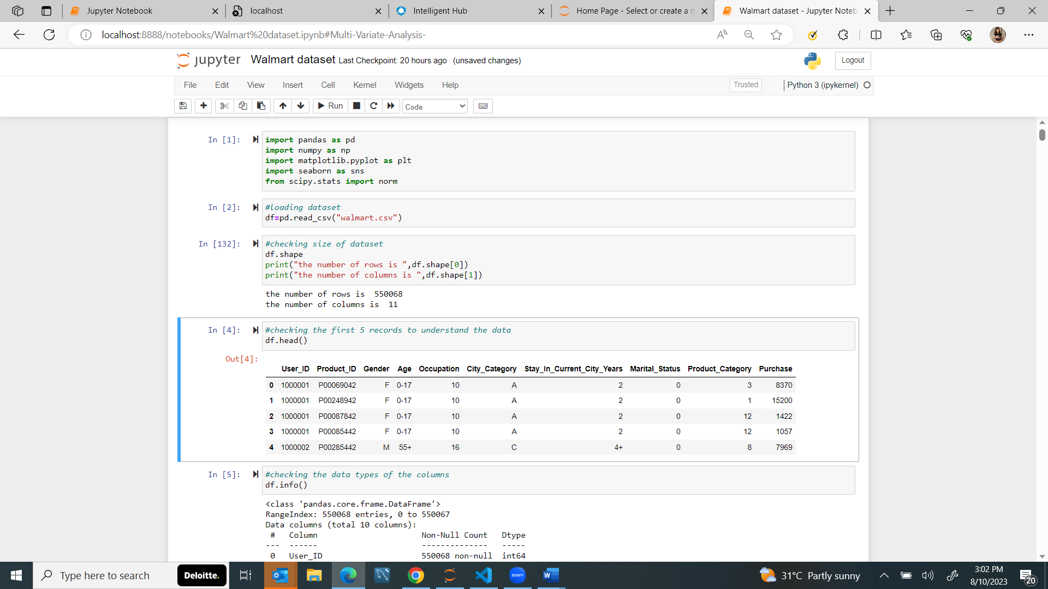

Checking How the dataset looks like-

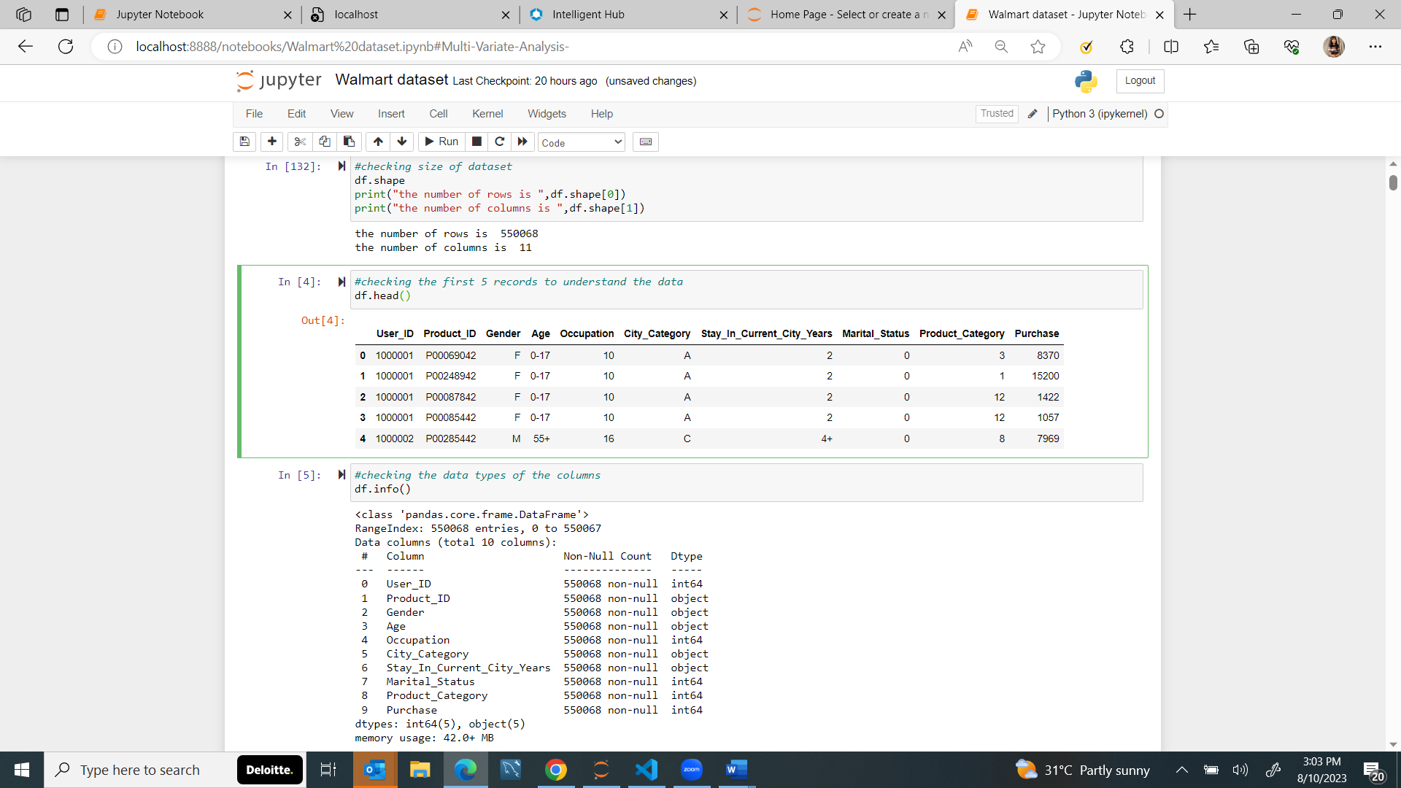

**Checking count of non null and data types of each columns-**

As we can see here, there are no null values in the dataset.

And the datatype of 5 columns are integer type and 5 are of object data types

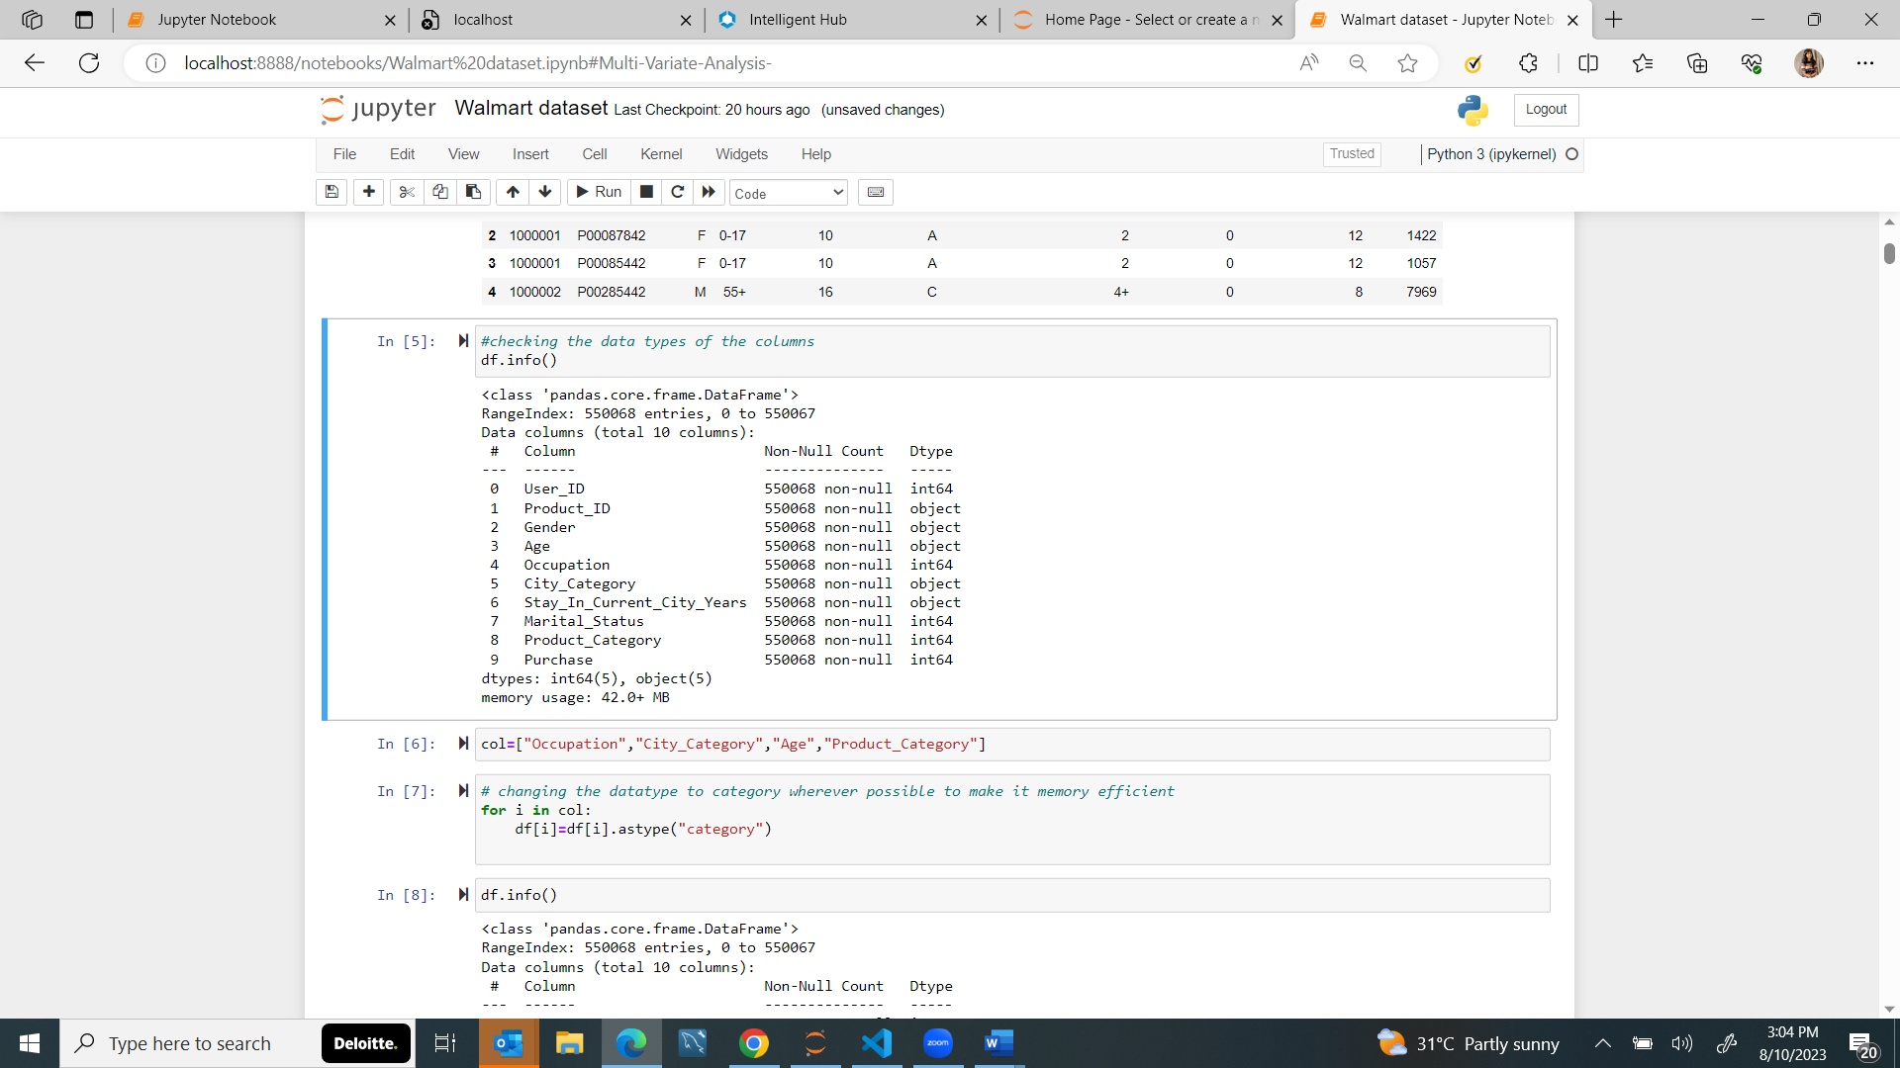

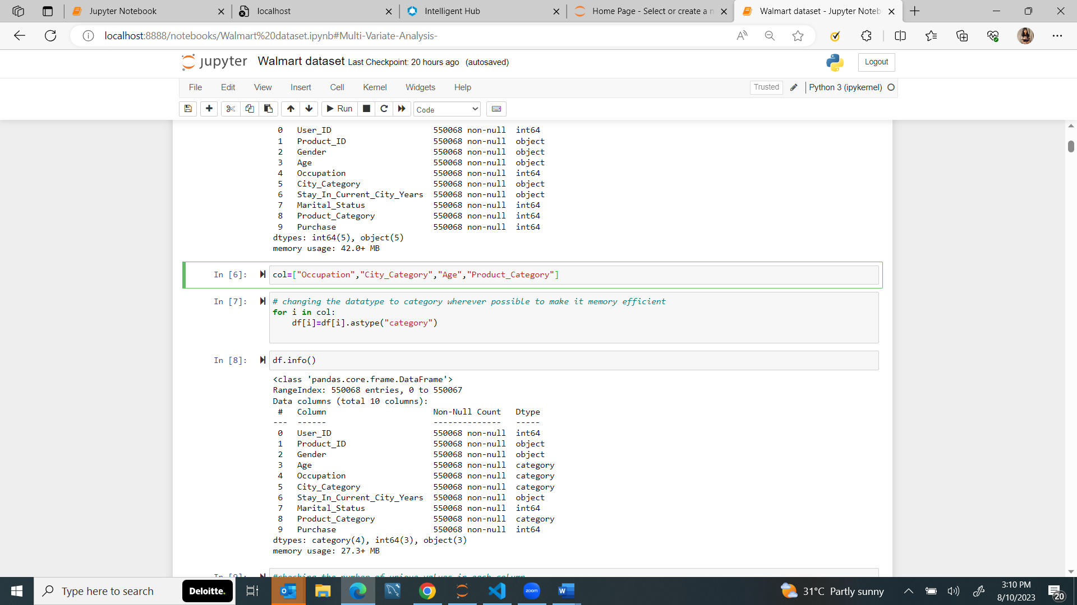

**Changing Datatype of columns where ever possible-**

The total memory usage decreased from 42 to 27Mb(35% decrease)

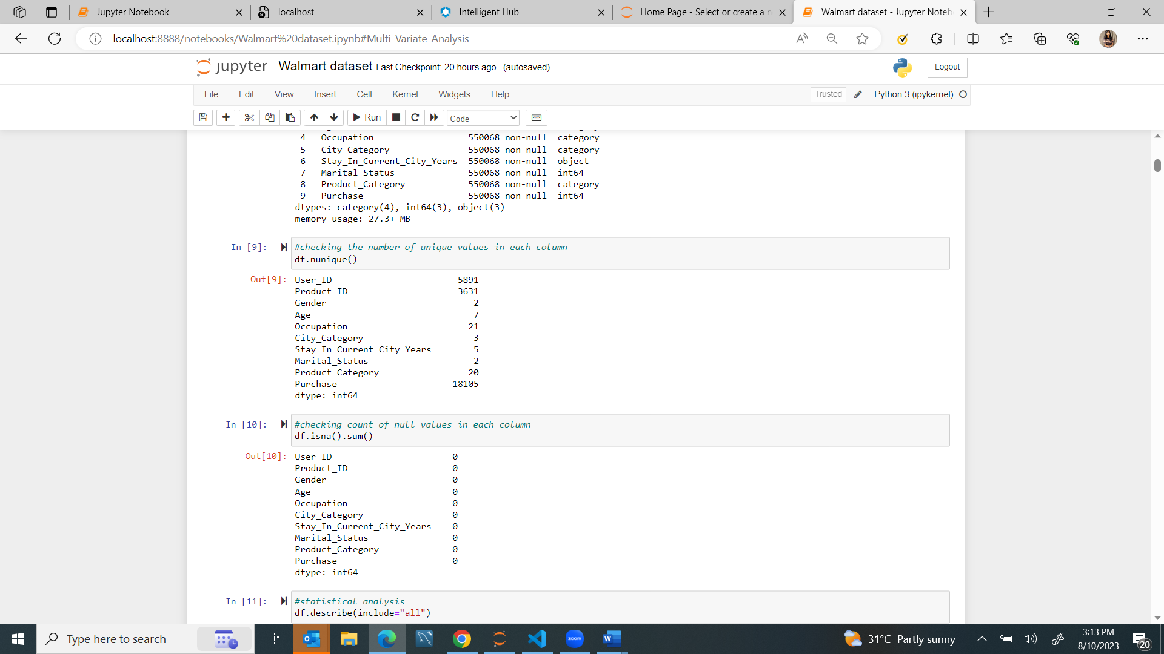**Checking unique values in each column:**



**Checking Null values-**

**Statistical Analysis-**

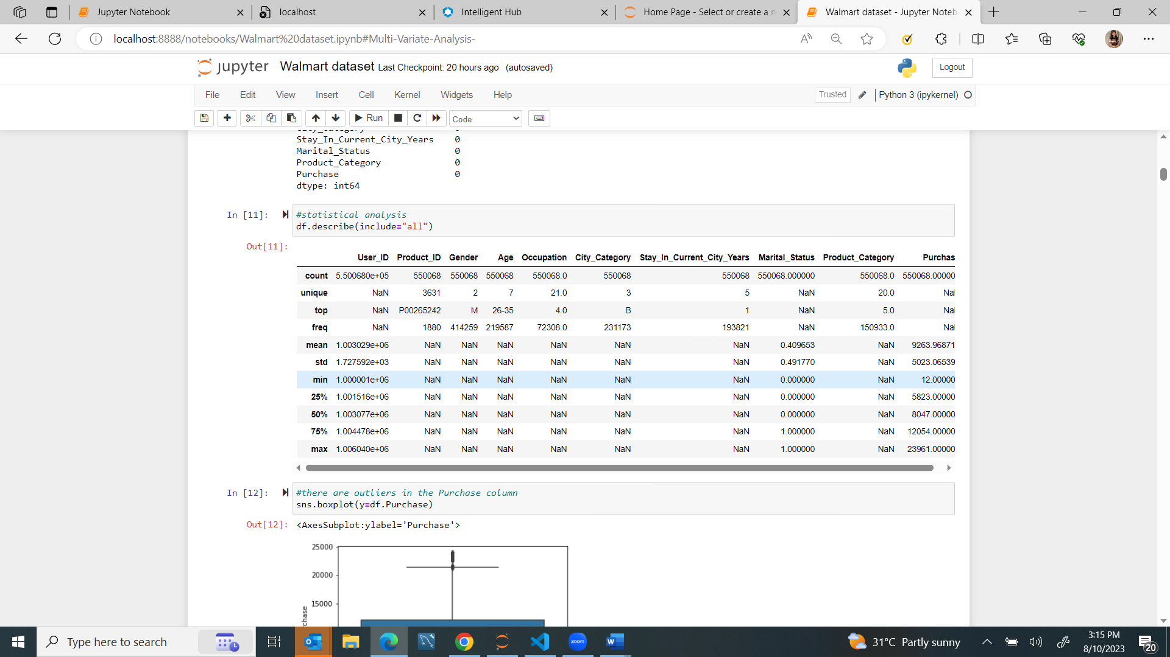

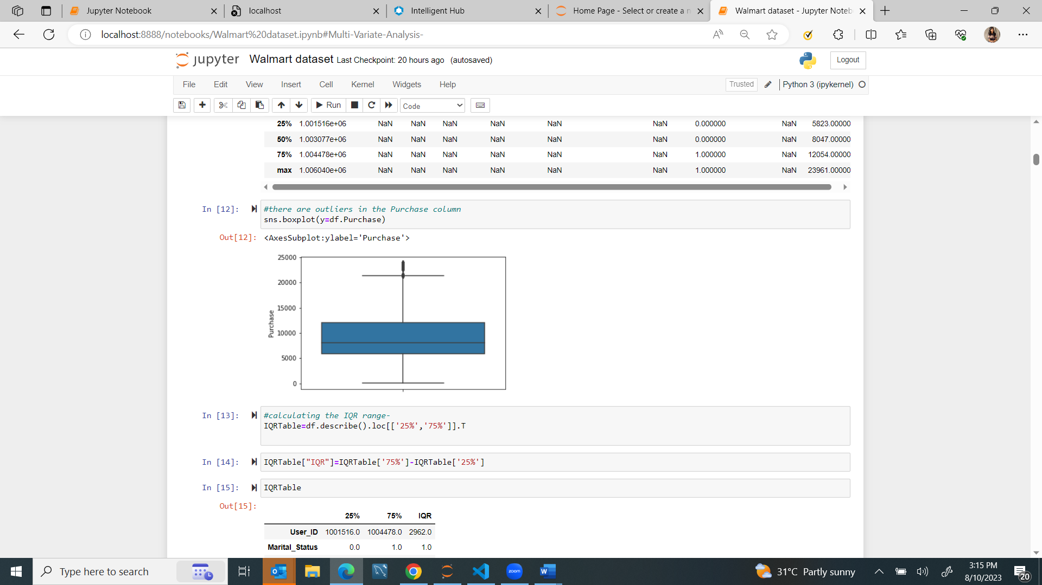**Check for Outliers-**

As we can see in the boxplot here ,The column purchases has outliers in the data.So will be replacing the outlier values by the upper limit of IQR value.

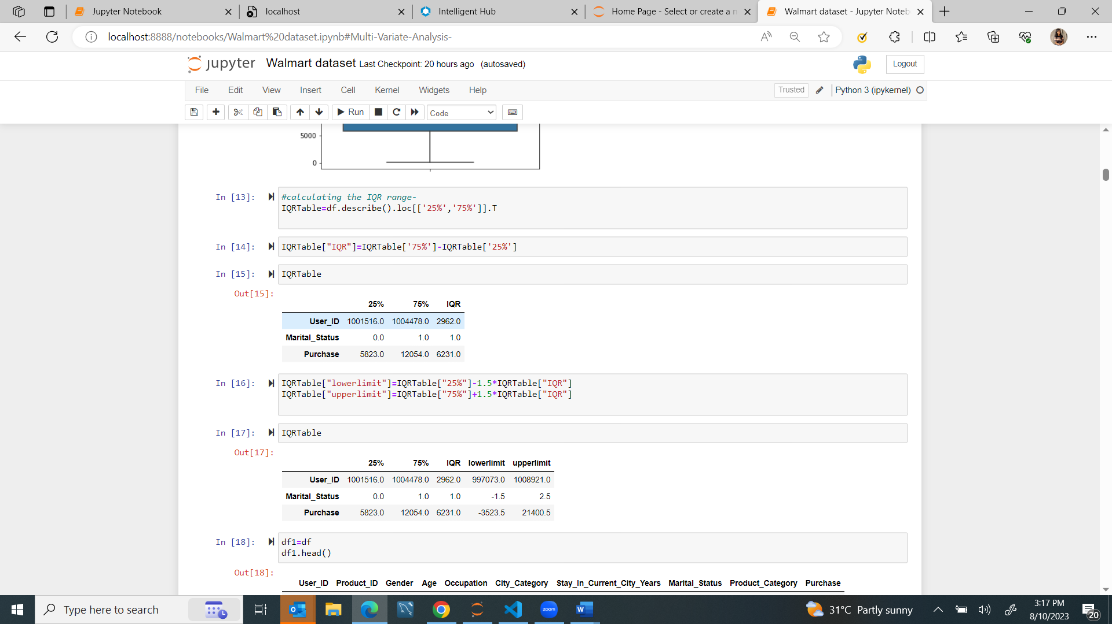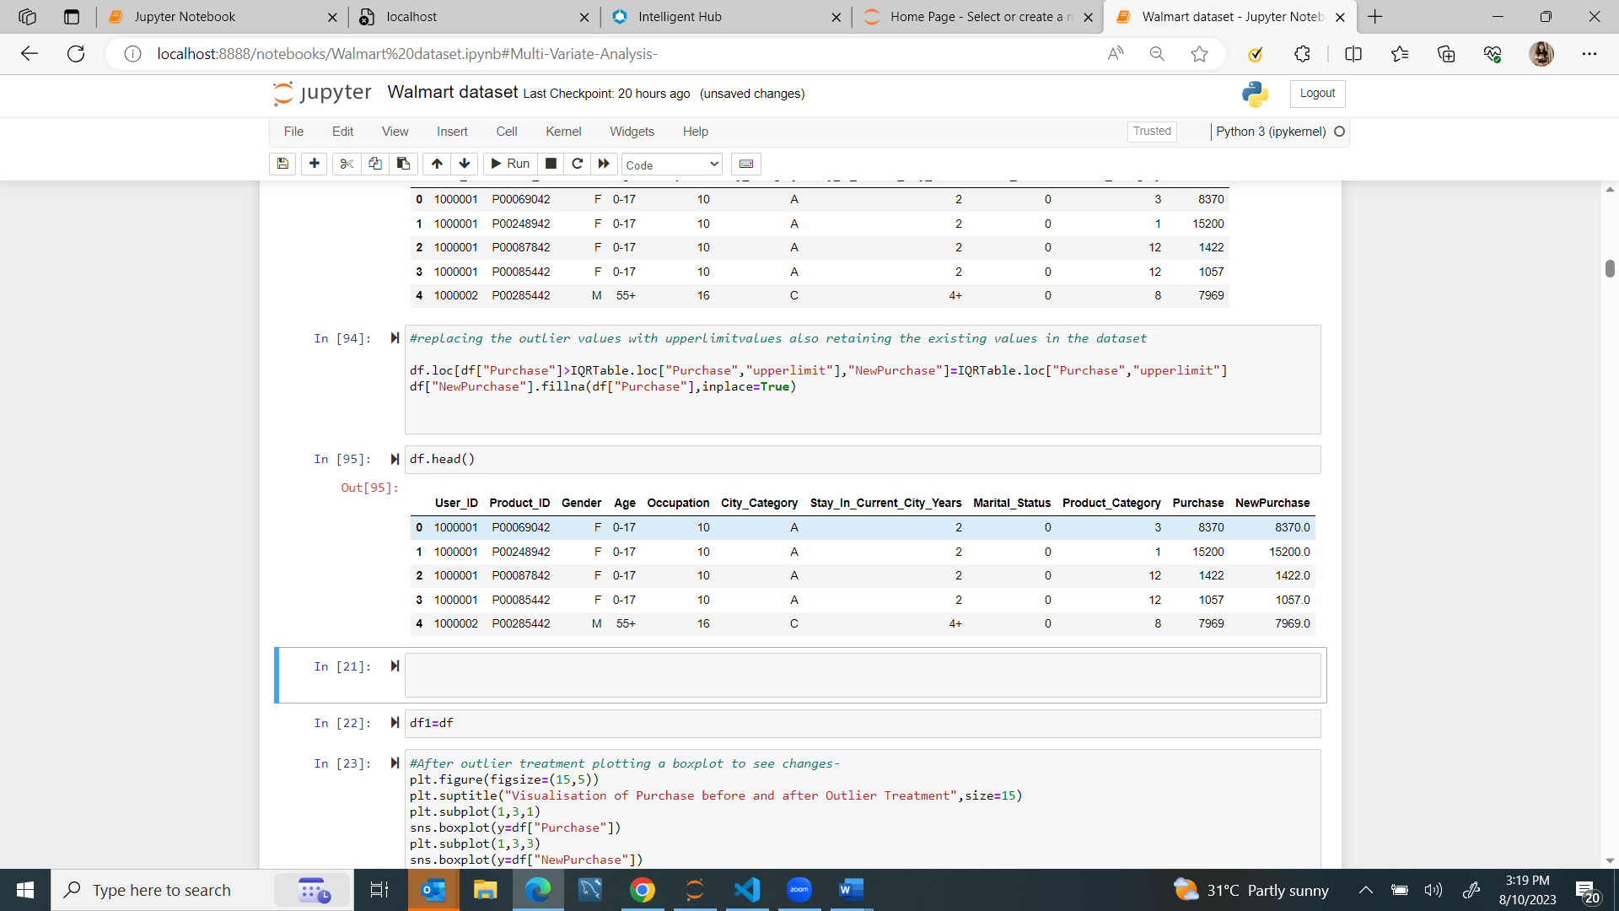

After outlier treatment, this is how the data looks like for purchases column-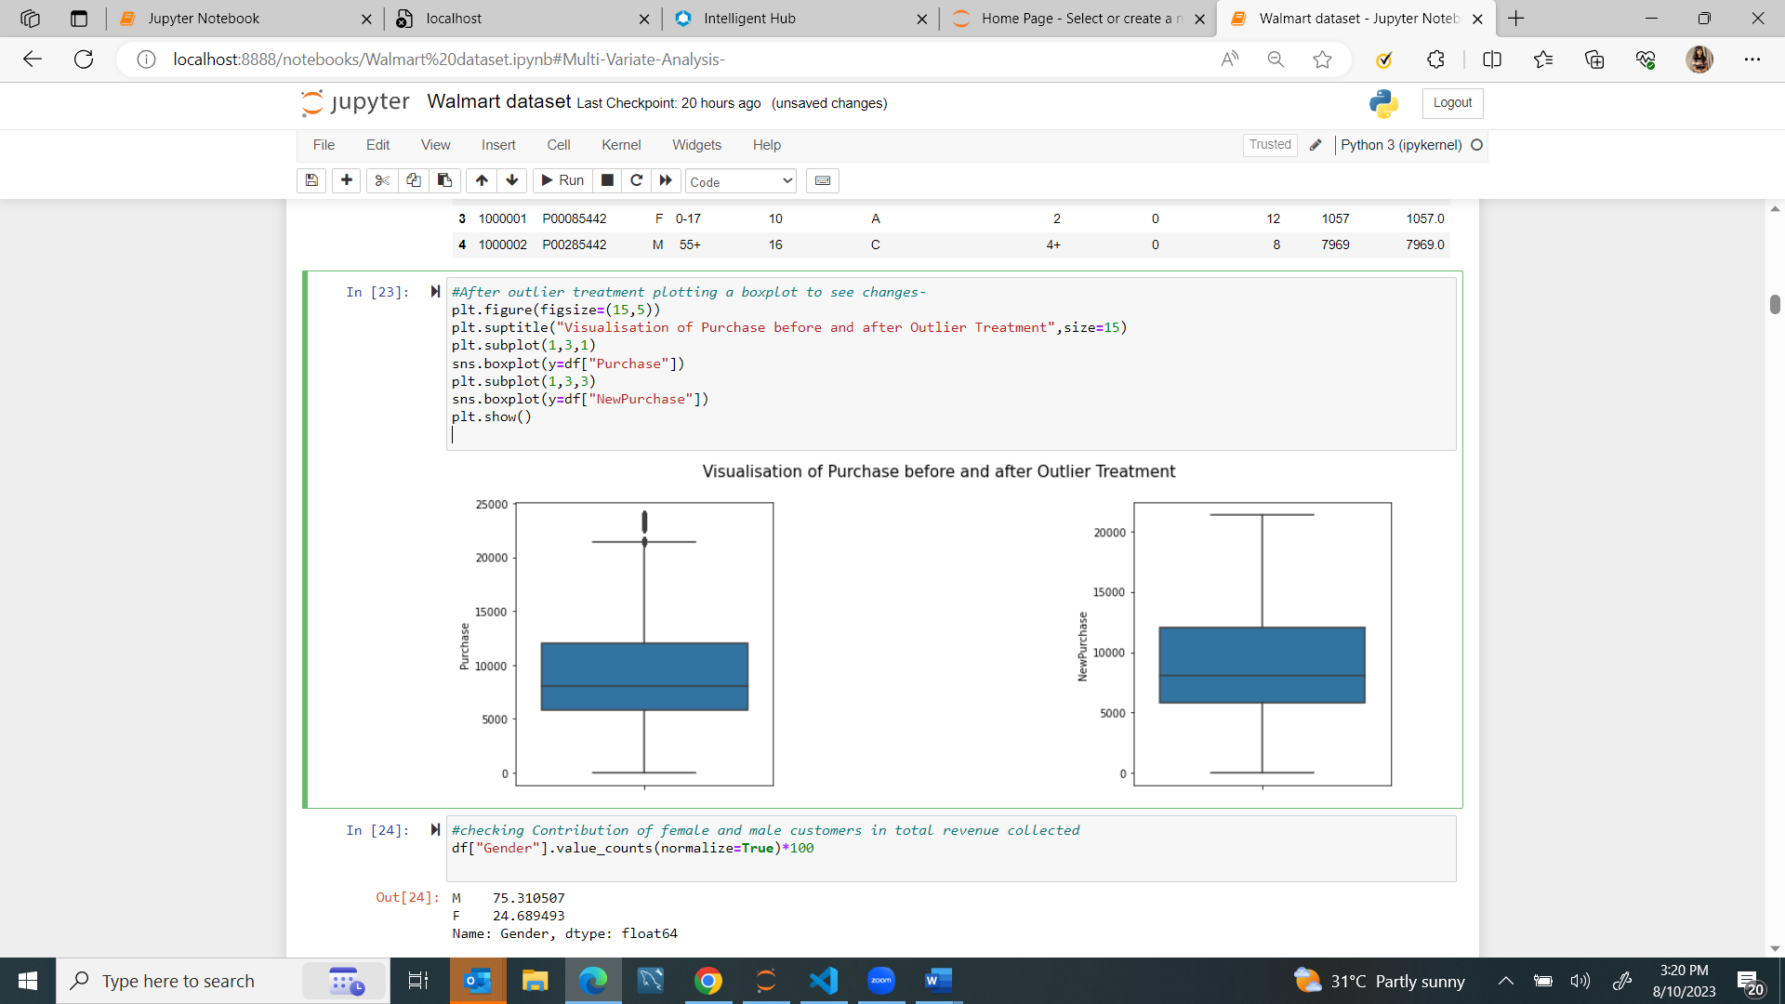

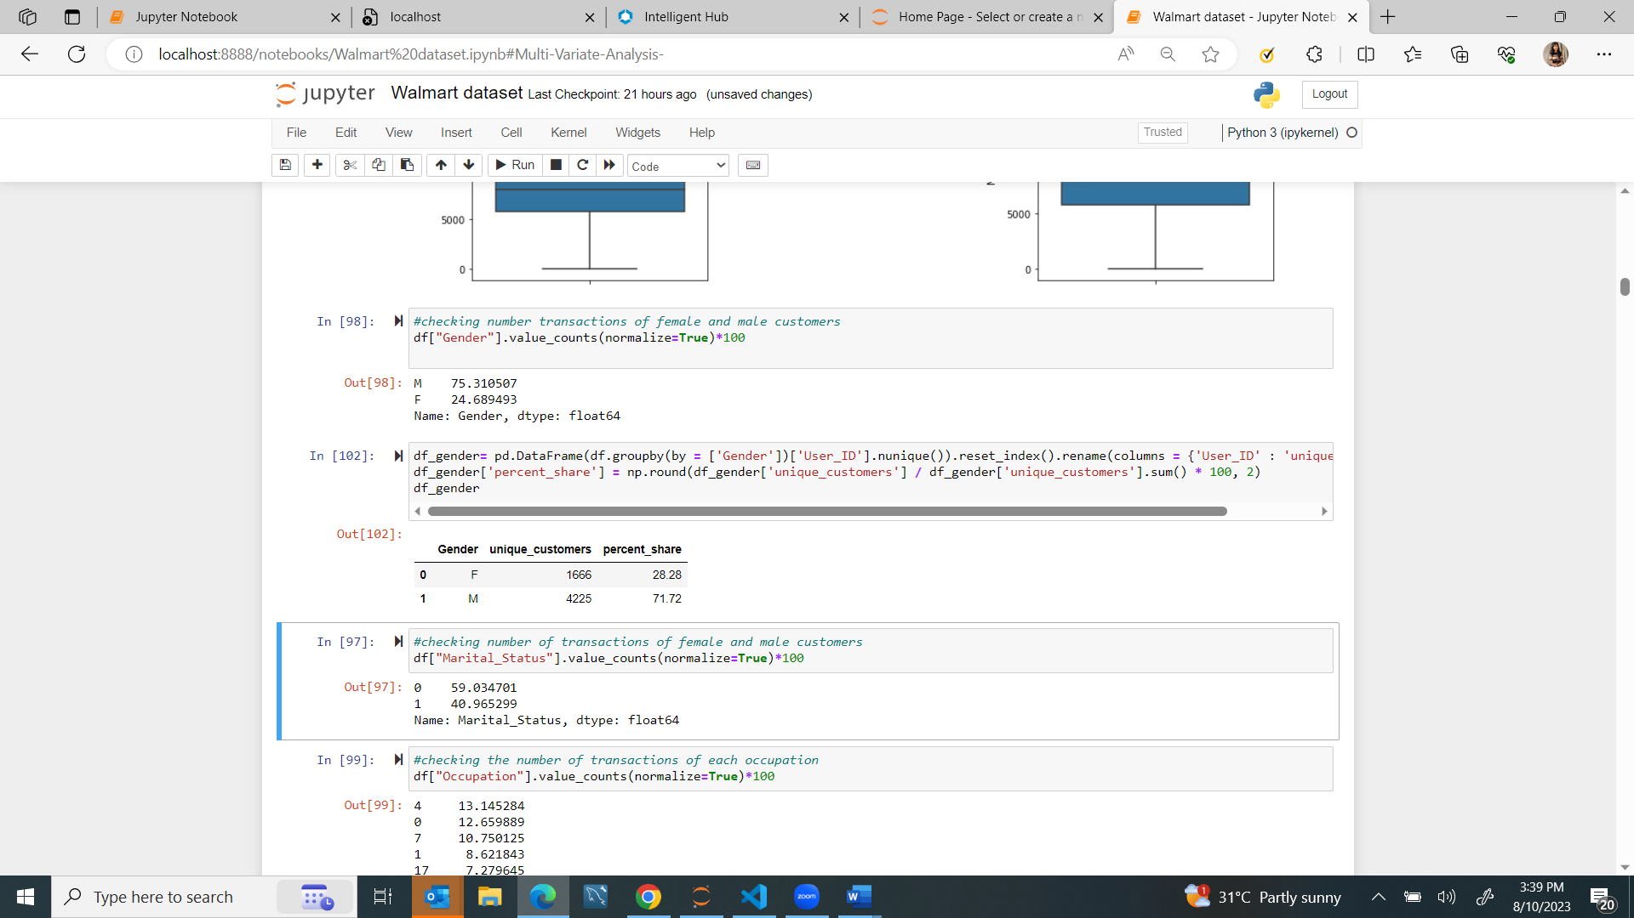**Unique customers in each gender-**

71.5% of total customers in the dataset ismale and 28.5% is females

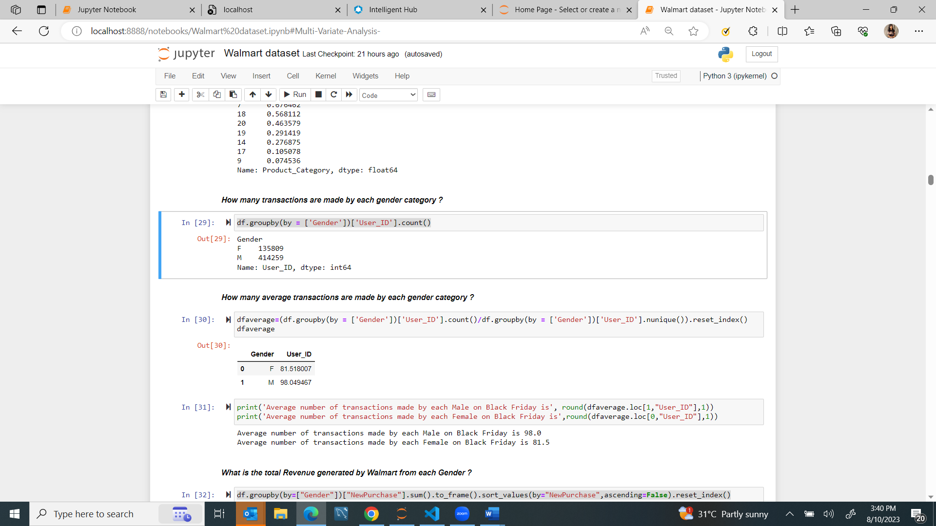**Number of transactions contributed by each gender-**

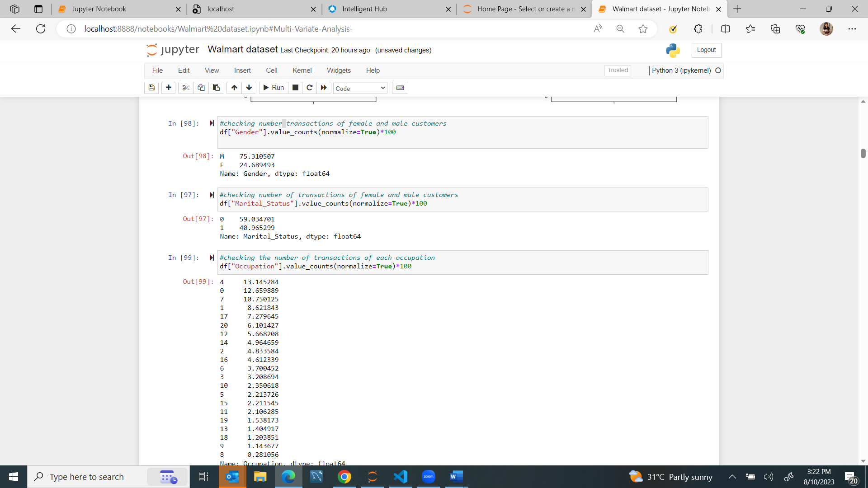

* The total number of transactions by male and female are 135809 and 414259 respectively .
* In percentage 75% of the total items transacted on black Friday sale were done by Males.
* 25% were done by females
* Average number of transaction by females is 81
* Average number of transactions by males are 98

**Number of transactions contributed by marital_status 1 and 0-**

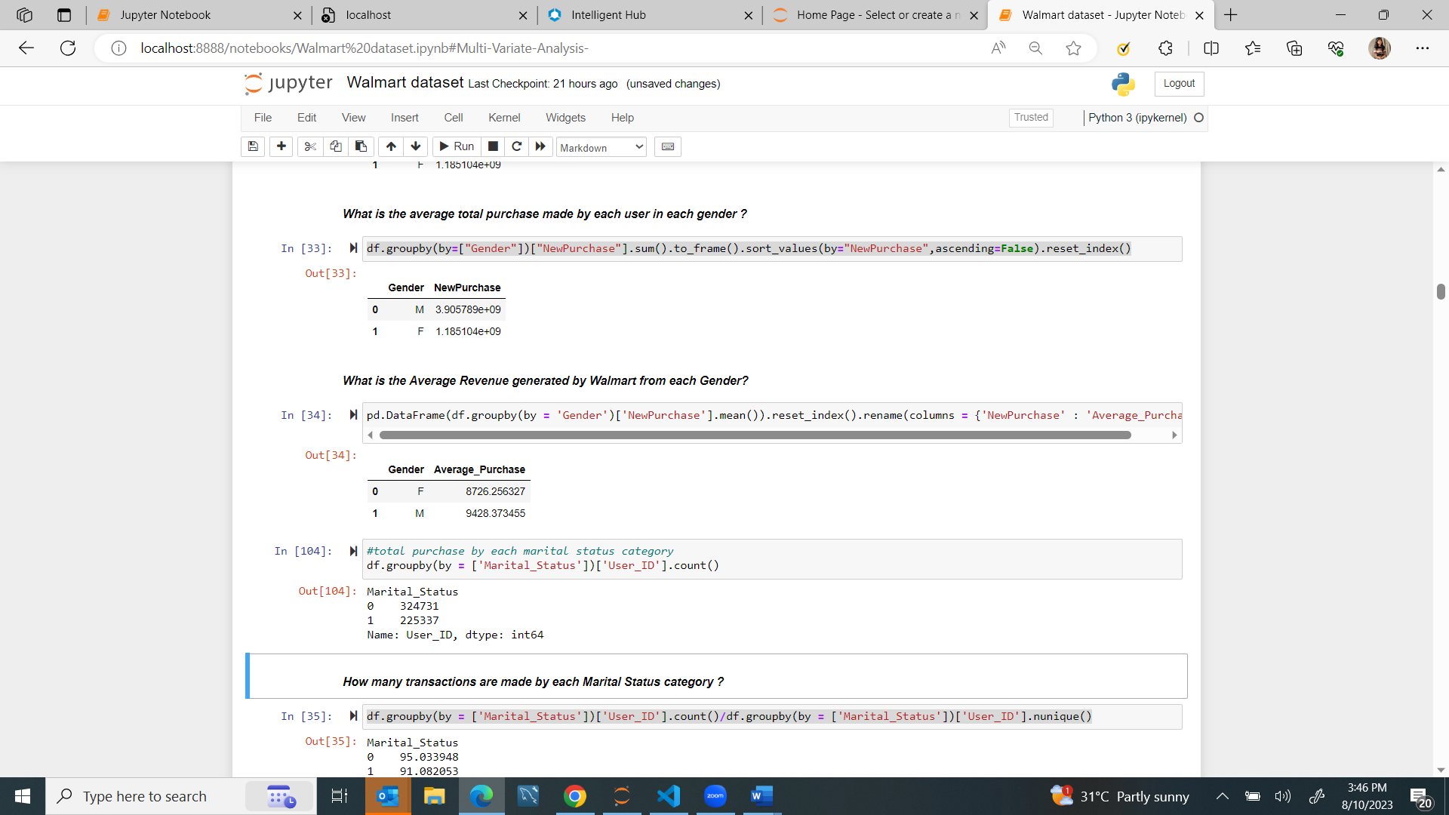



* 59% of the total items transacted on black Friday sale were done by Singles .
* 41% were done by married.
* The total purchases by married people is higher than that of singles.

**Revenue earned from Each Gender**

The total revenue earned from males is 3times higher than that earned from females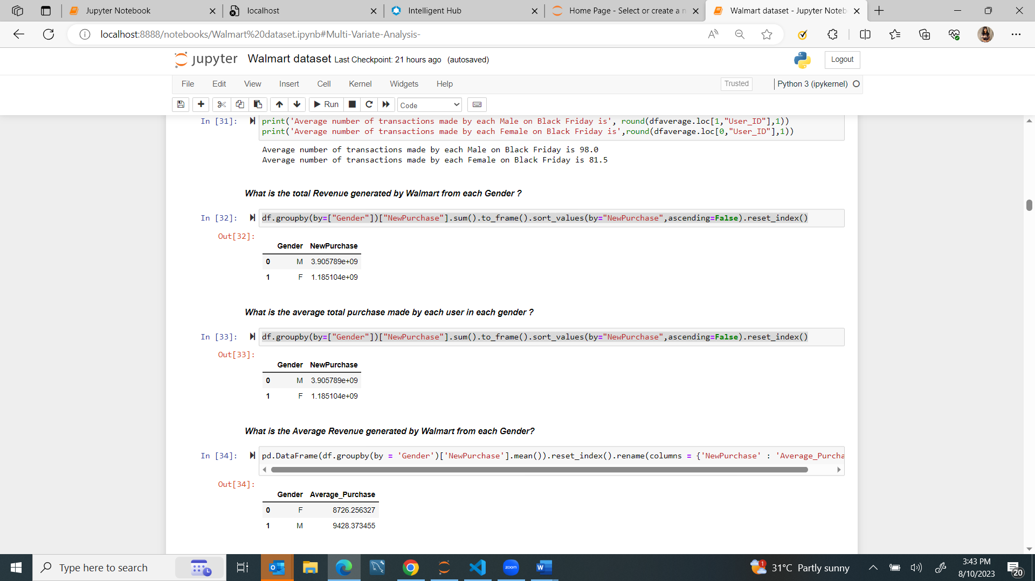

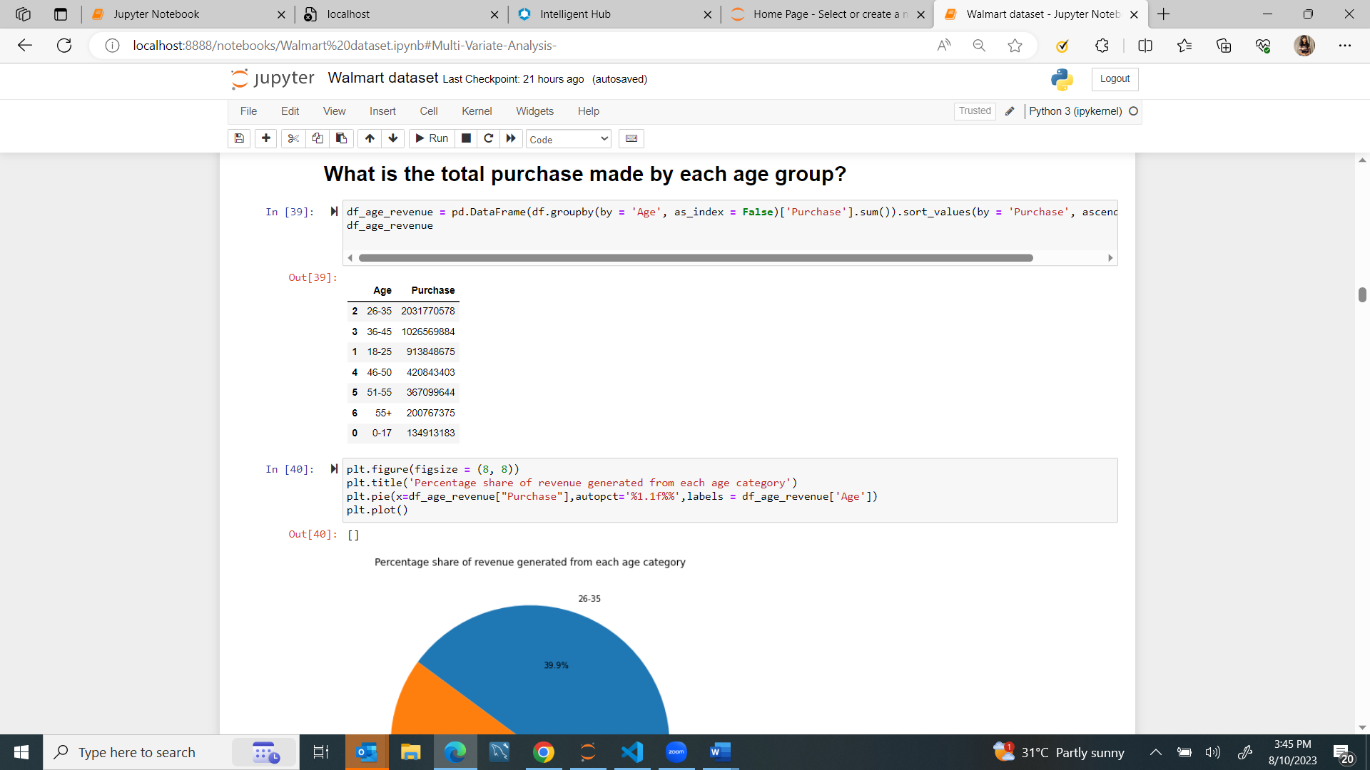**Revenue earned from Each Age group:**

* Customers of age 26-35 have made the highest pucrhases
* Customers of age 0-17 made the lowest amount of purchases.

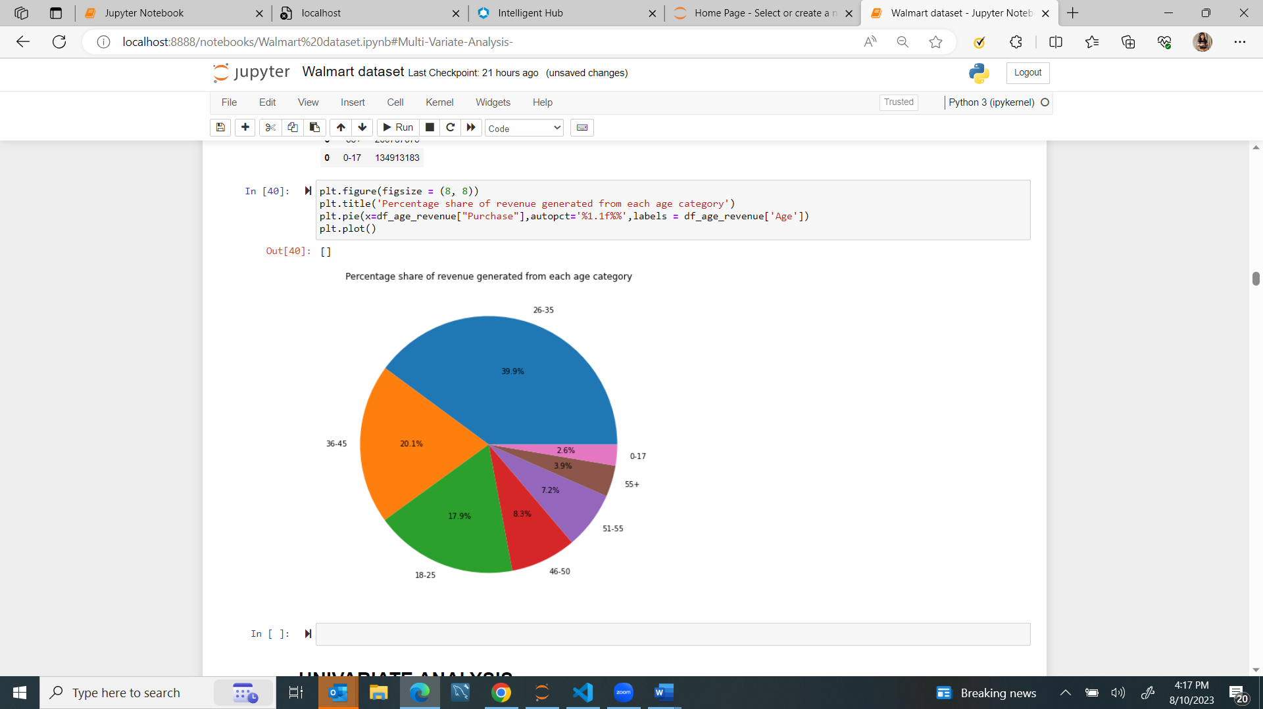

**UNIVARIATE ANALYSIS**-

Quantitave analysis of column-

**Analysis on Age /Gender /city category/ marital status**-

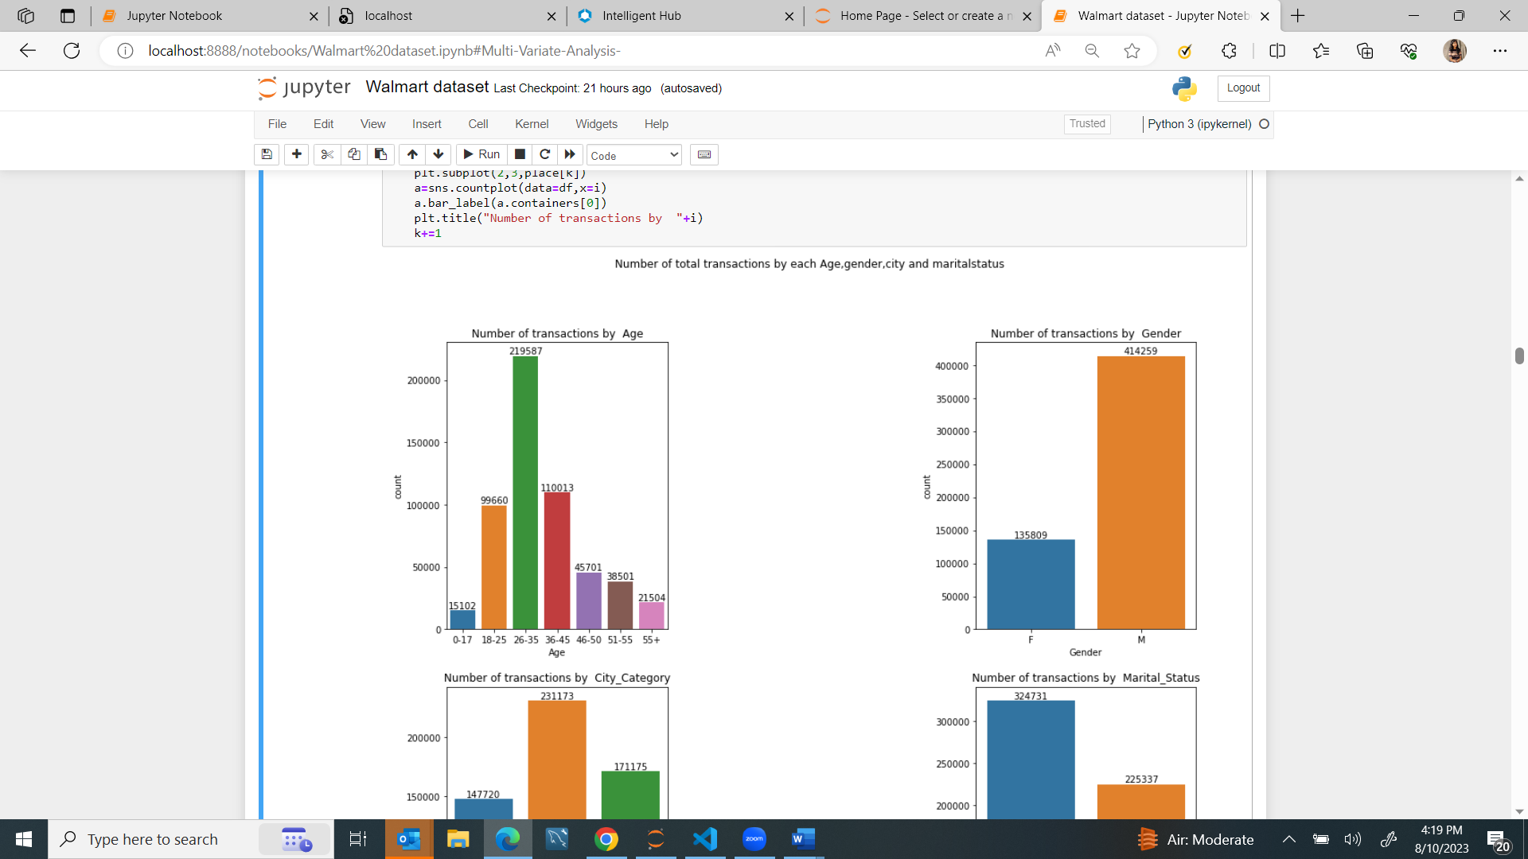

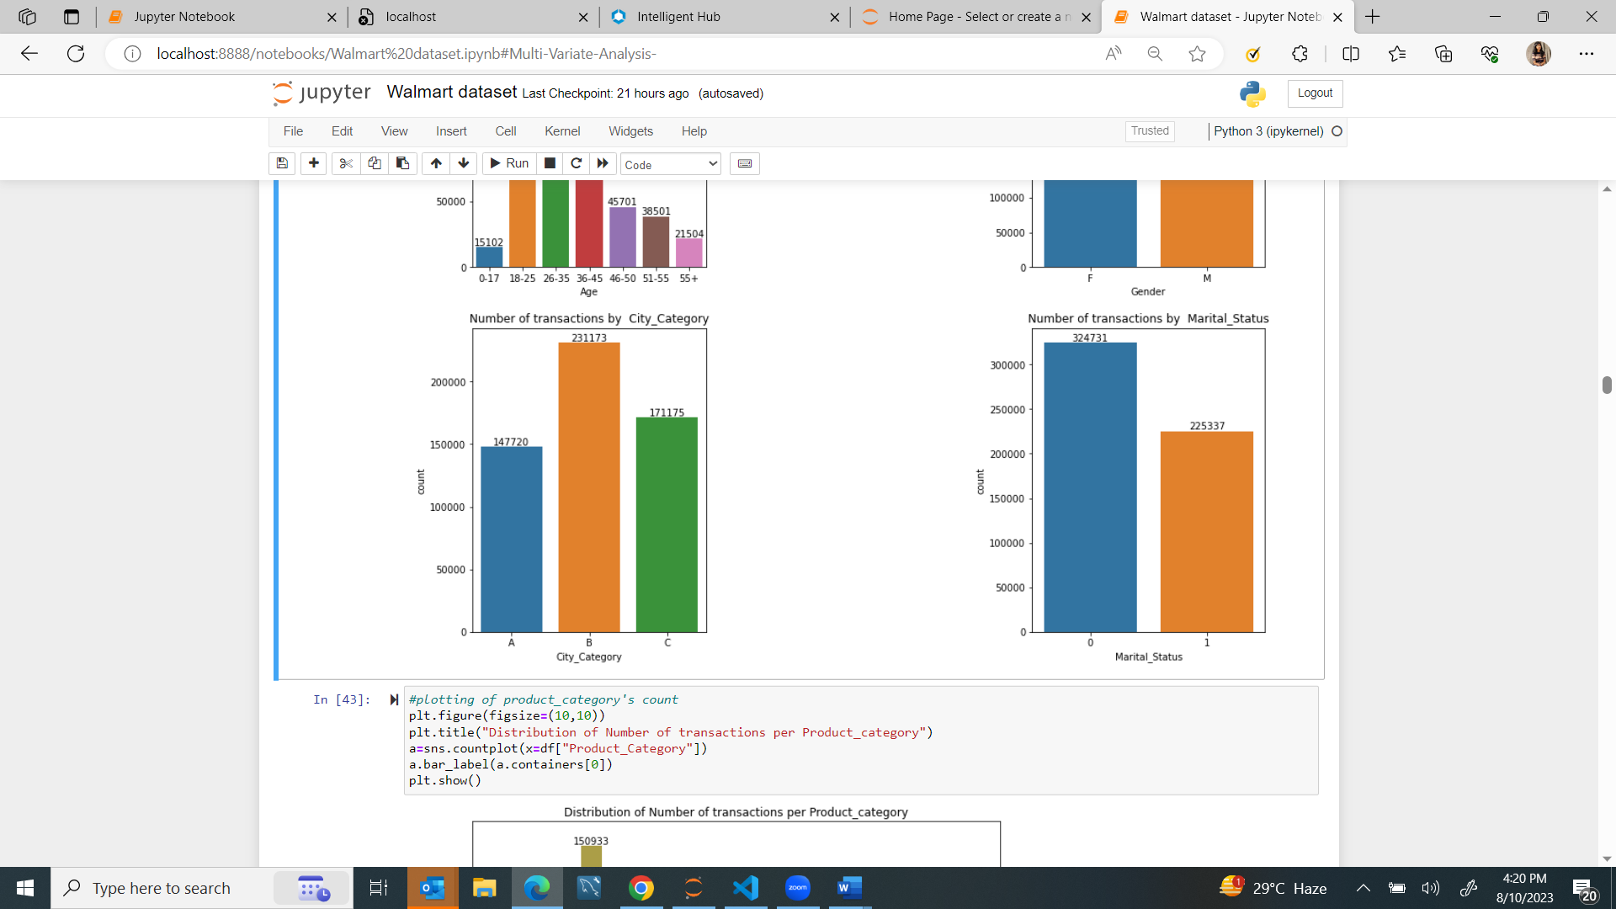

**Observations-**

* People of age 26-35 are making the higest transactions
* Gender wise, Males are the highest contributor to number of transactions on black friday sale
* City B has the highest number of transactions on sale day
* Single people tend to buy on Black Friday Sale

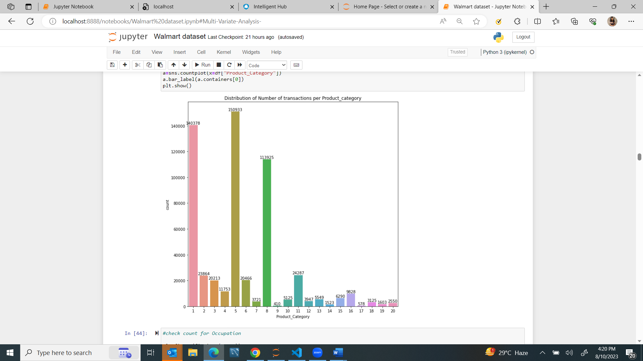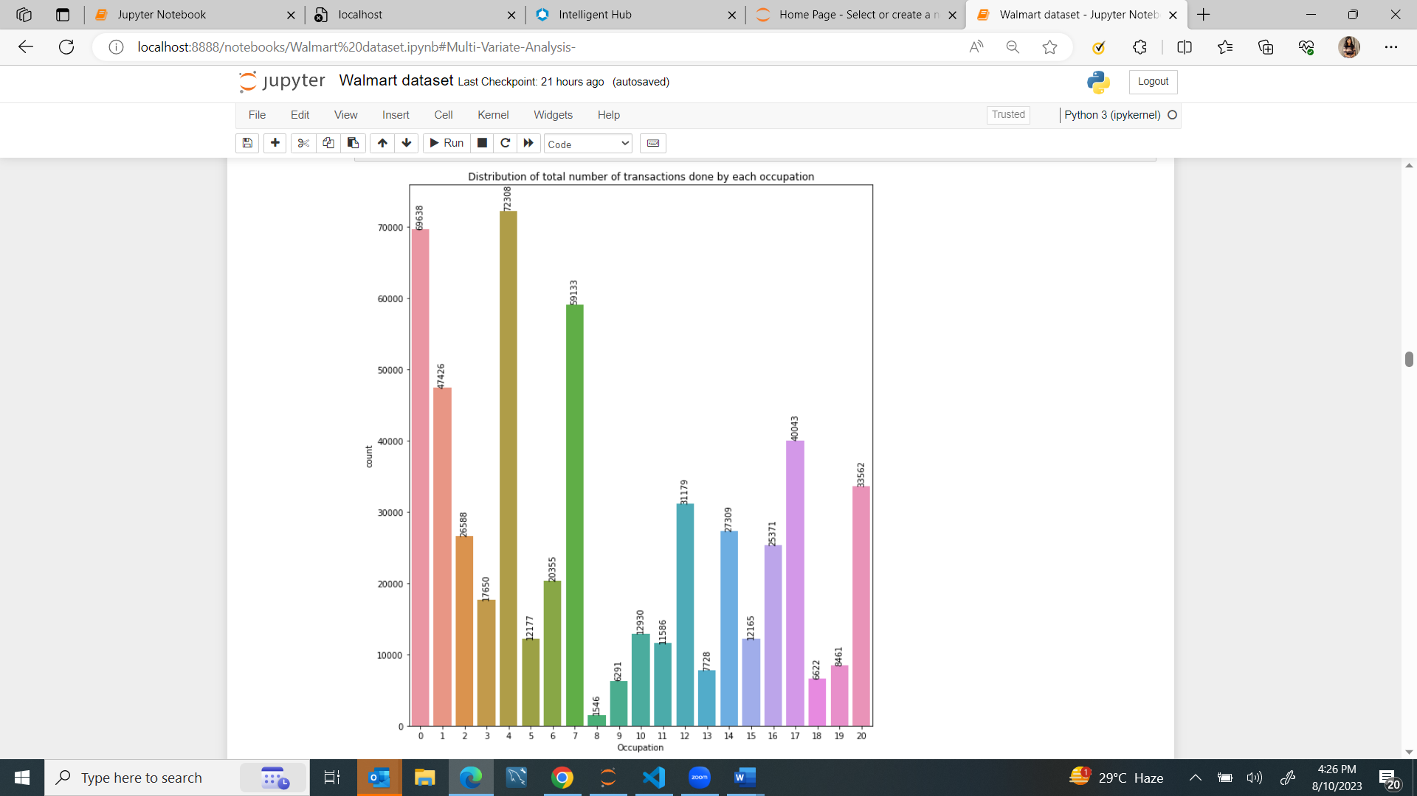**Univariate Analysis on Occupation /Product_Category /city stay**-

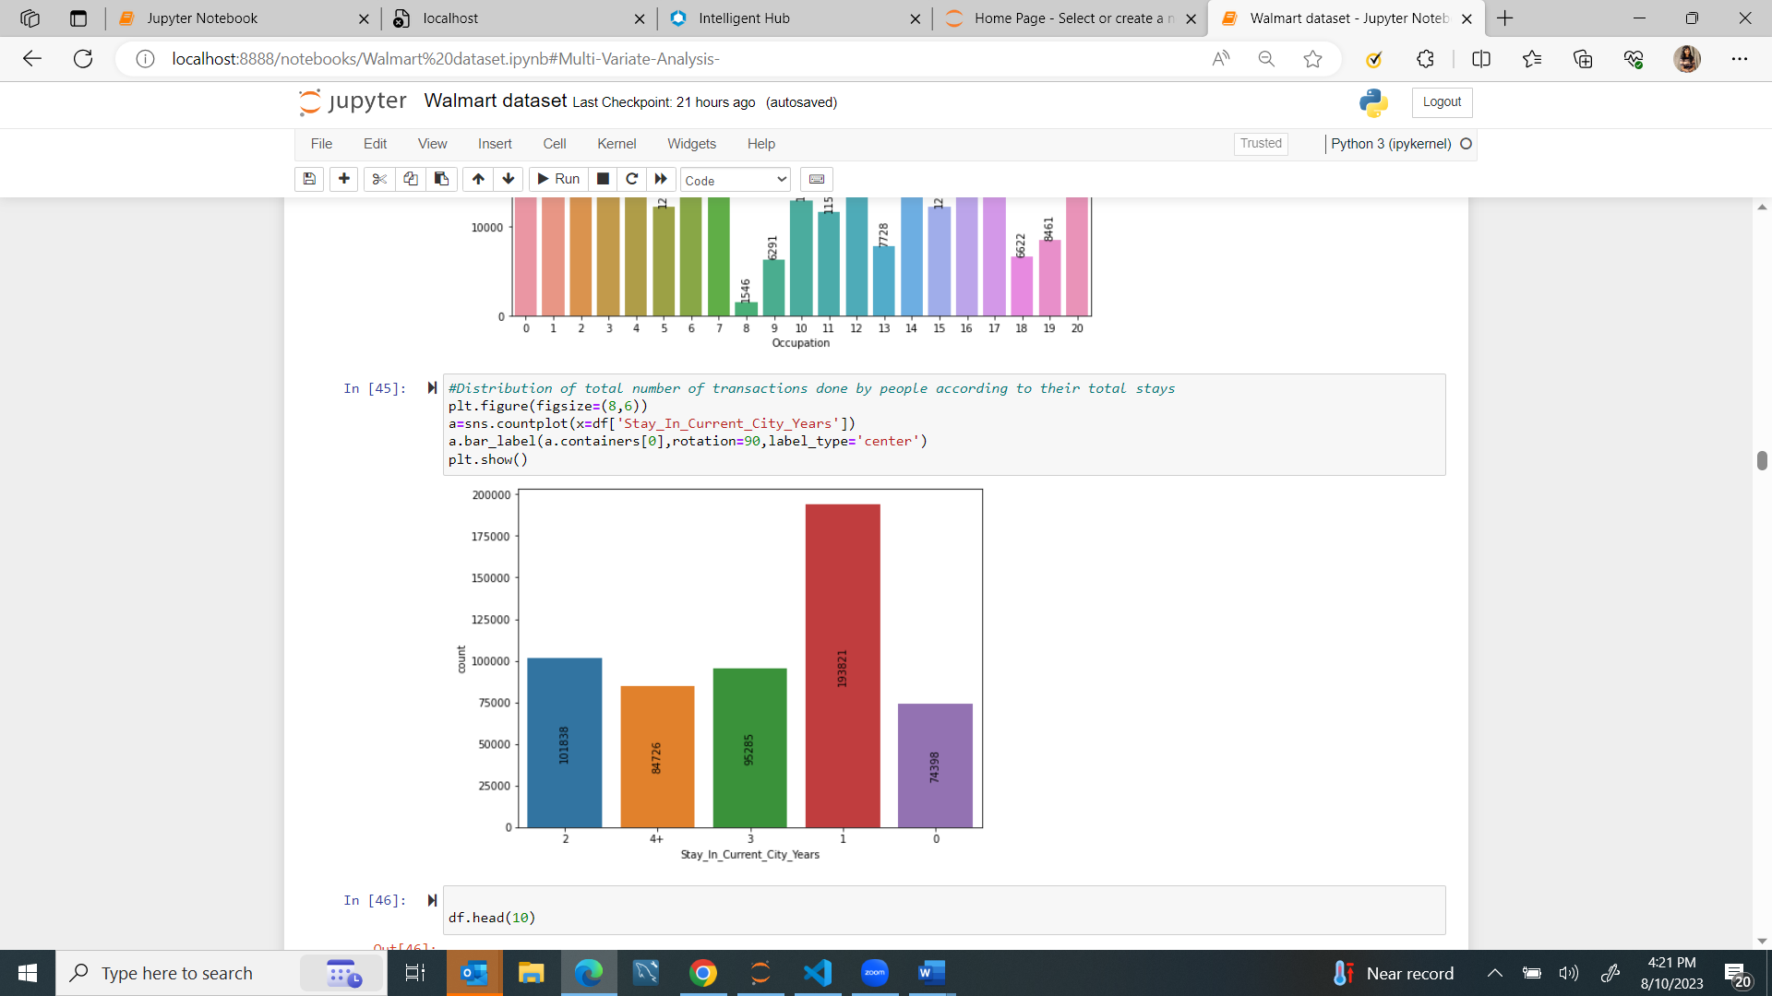

**Observations:**

* Occupation 0,4 and 7 has transacted the maximum times on sale day
* Product_Category 1,5 and 8 was bought the most on sale days
* People staying for 1 years has contributed majorly to sales .

**BIVARIATE ANALYSIS-**

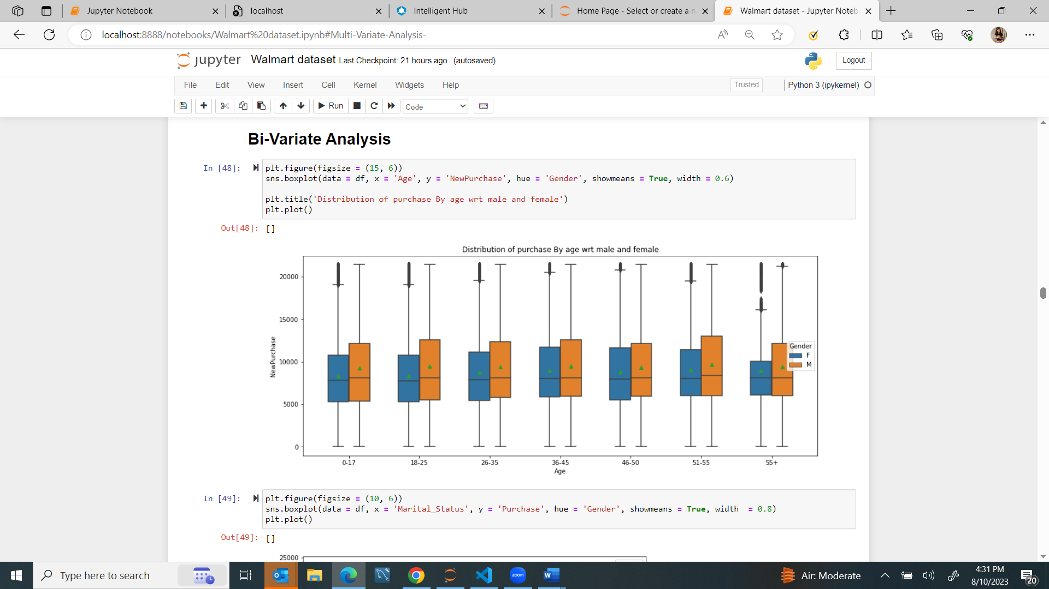Agegroup & gender

* As we can see here mostly females purchases have more of outliers than males.
* The median value for purchases in all age group is approximately same

MARITALSTATUS and GENDER

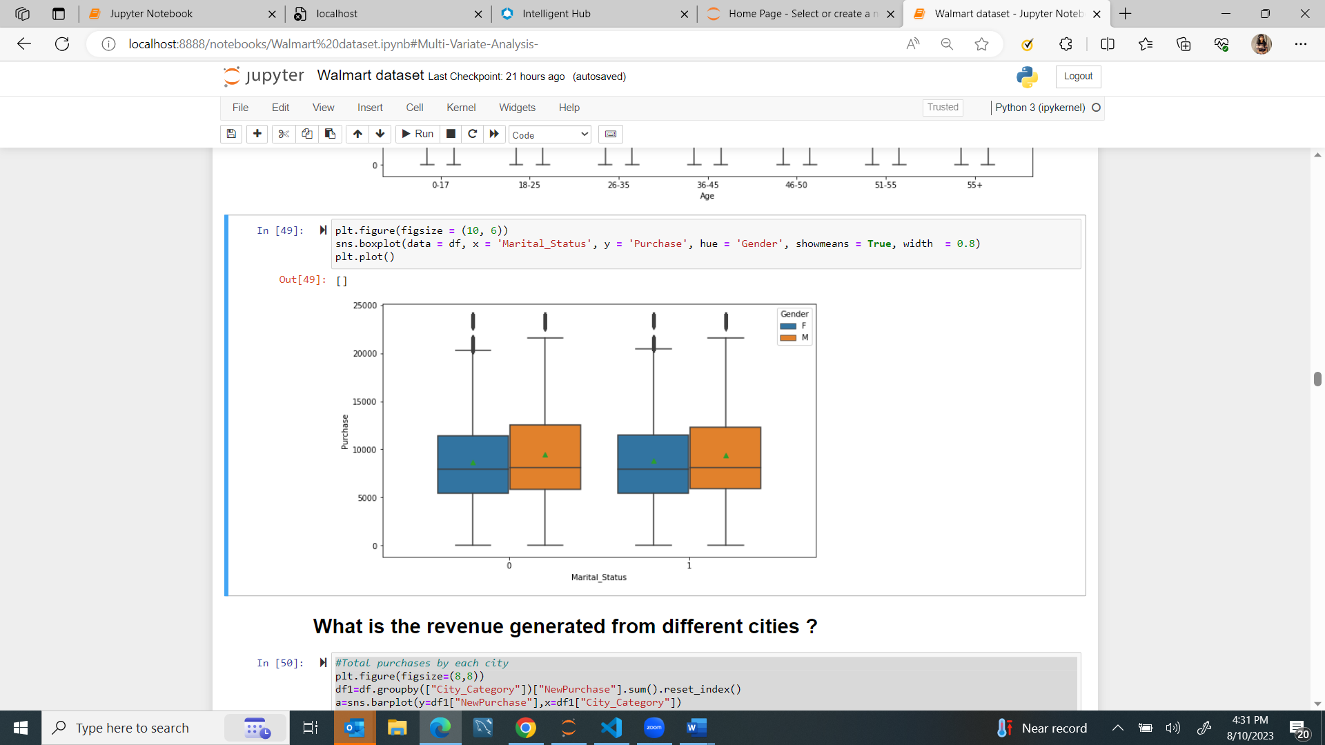

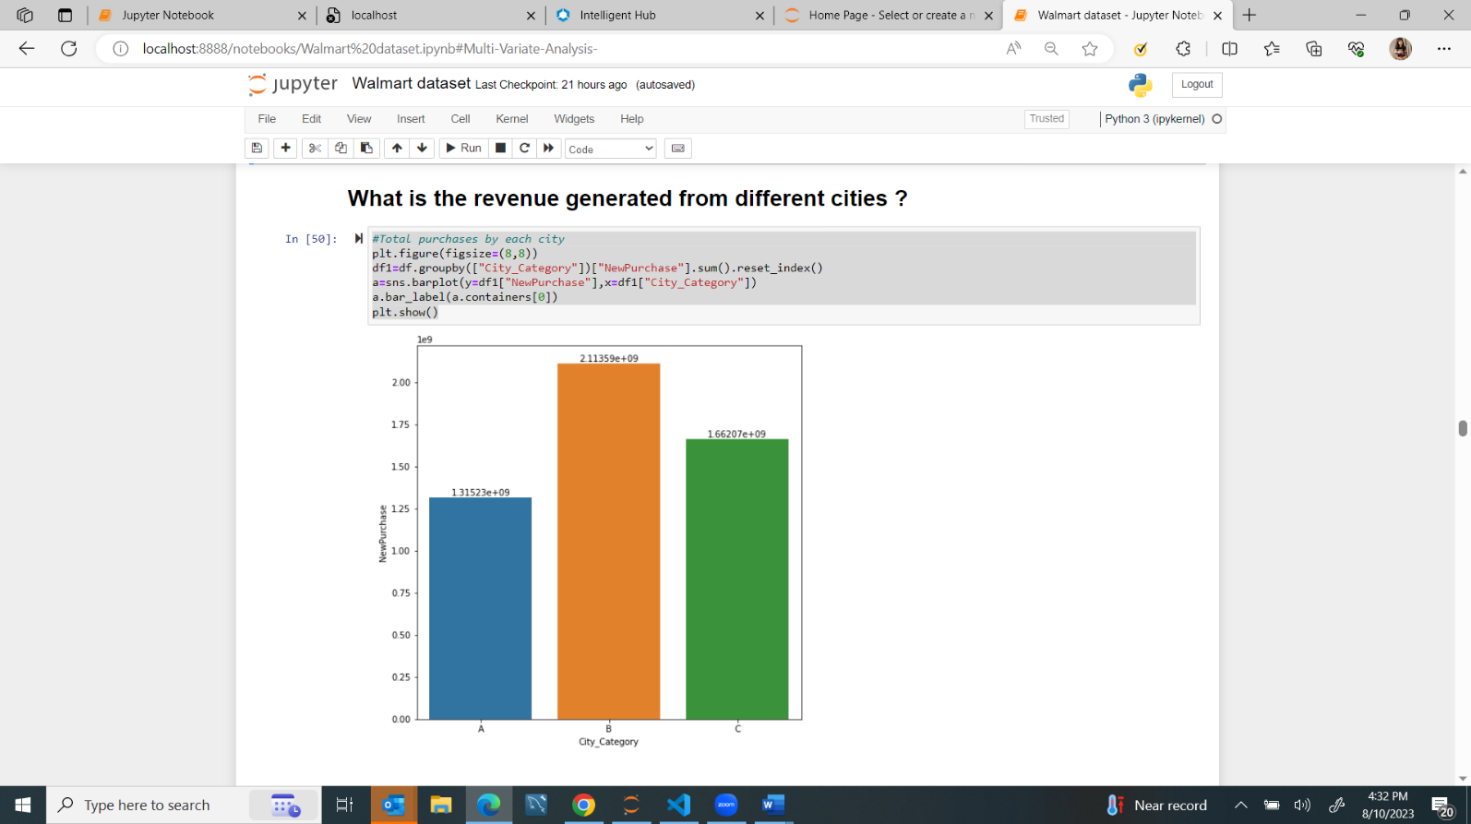Revenue and cities:

* City B has the highest amount of Purchases followed by C and A

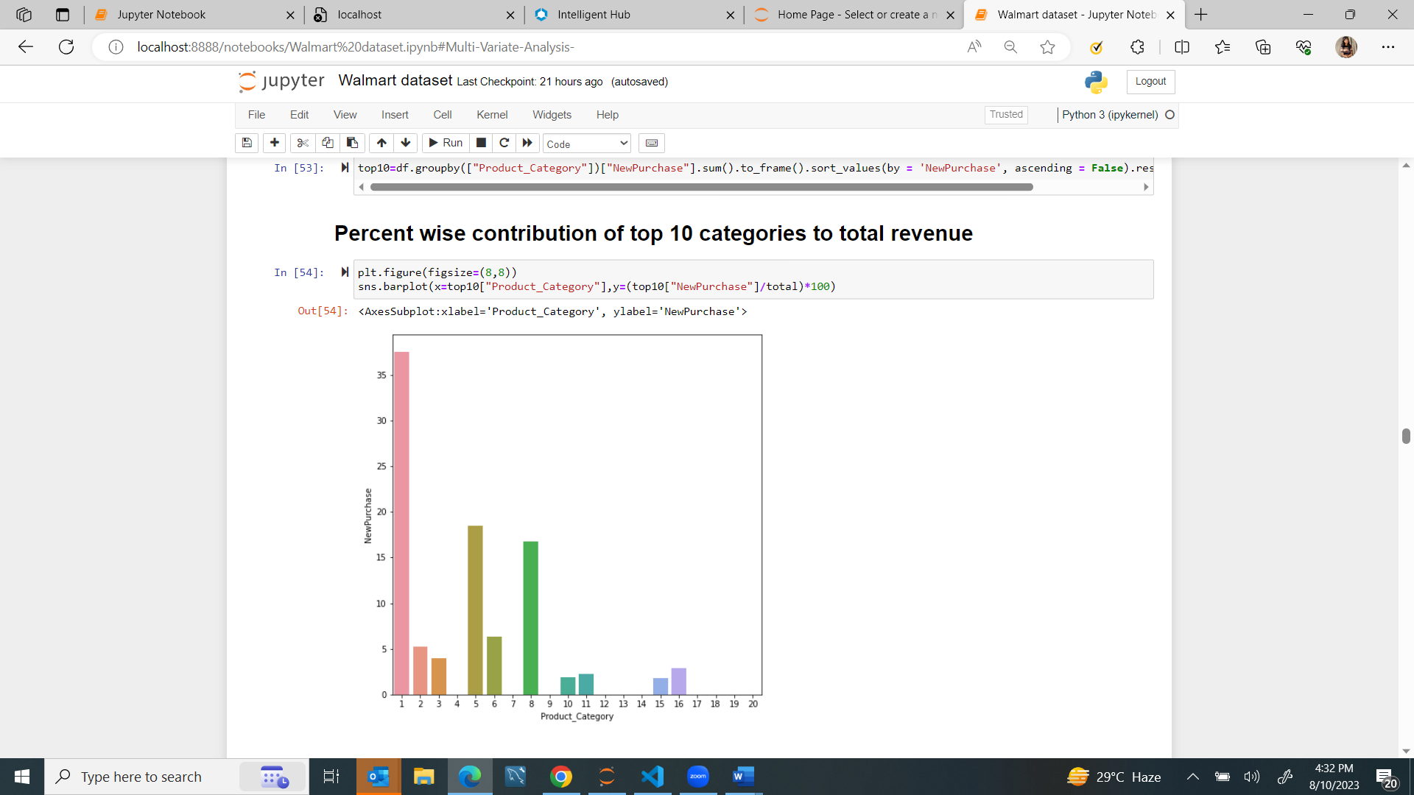

Products

**What is the contribution of each occupation to revenue?**

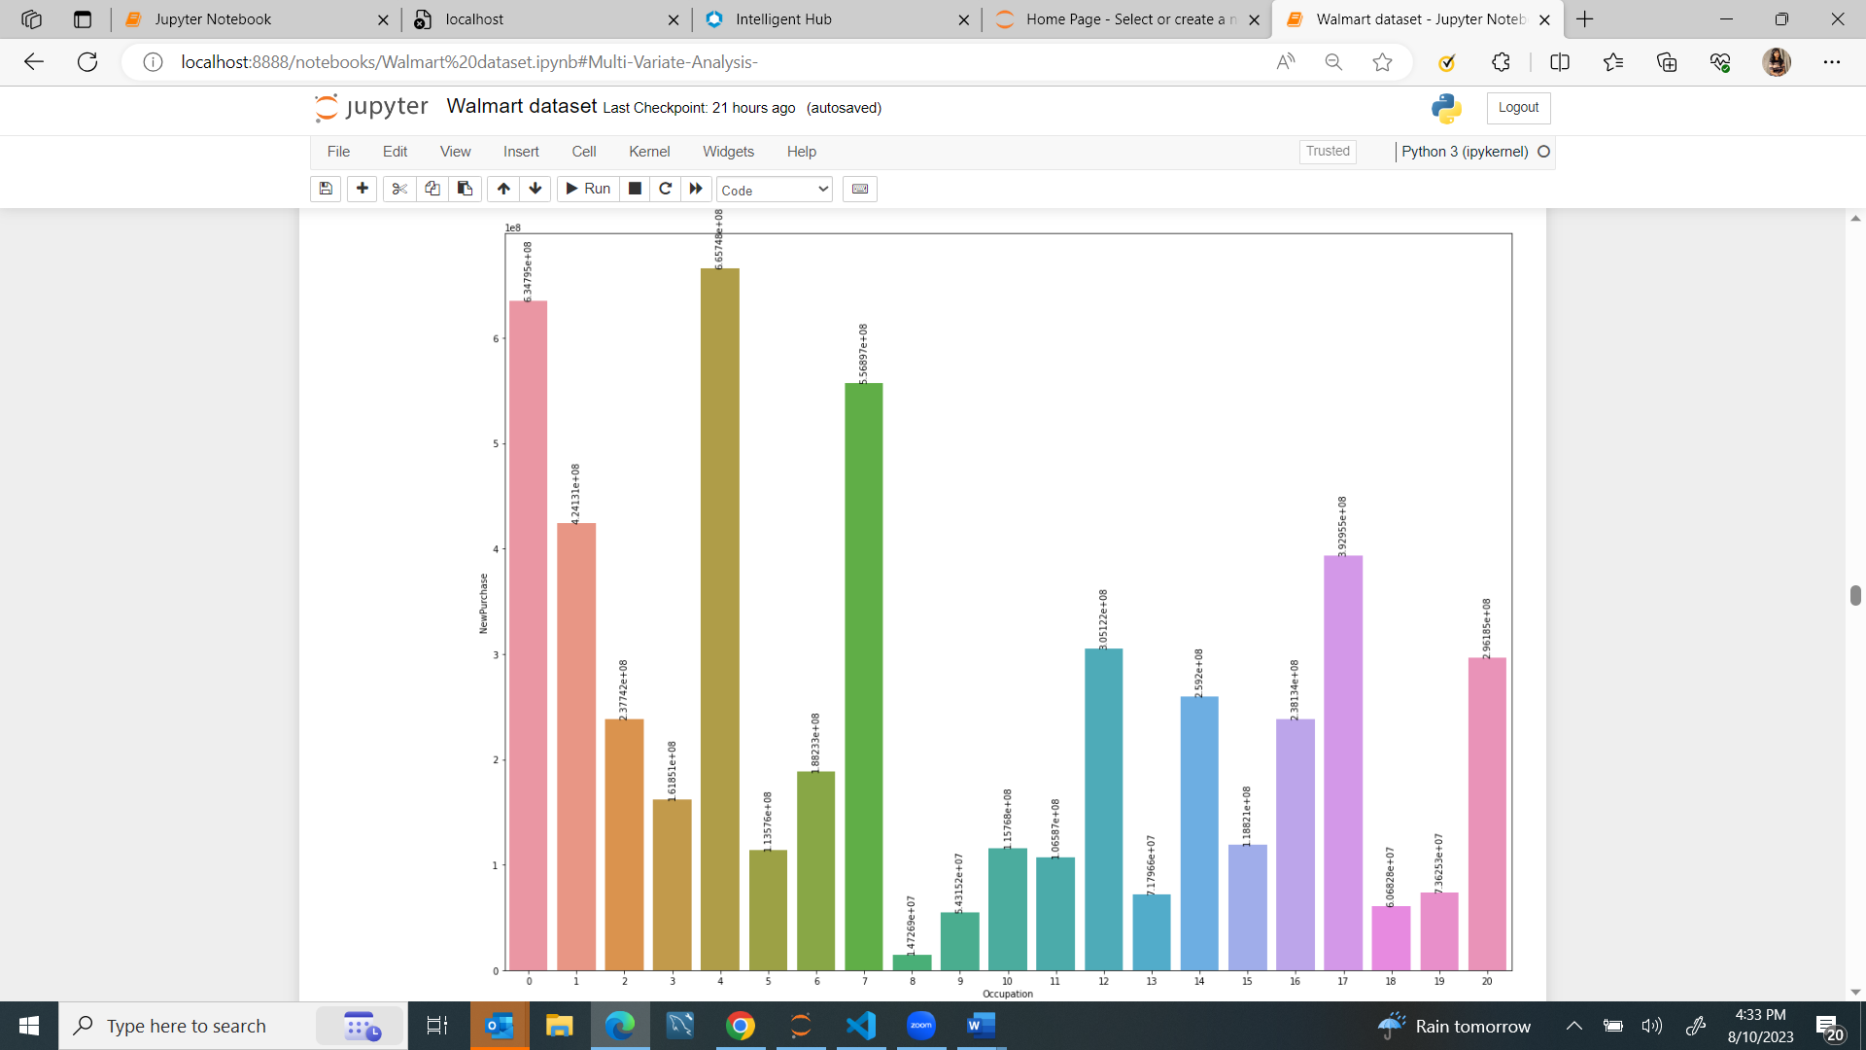

**What is the contribution of each AGE-GROUP to revenue?**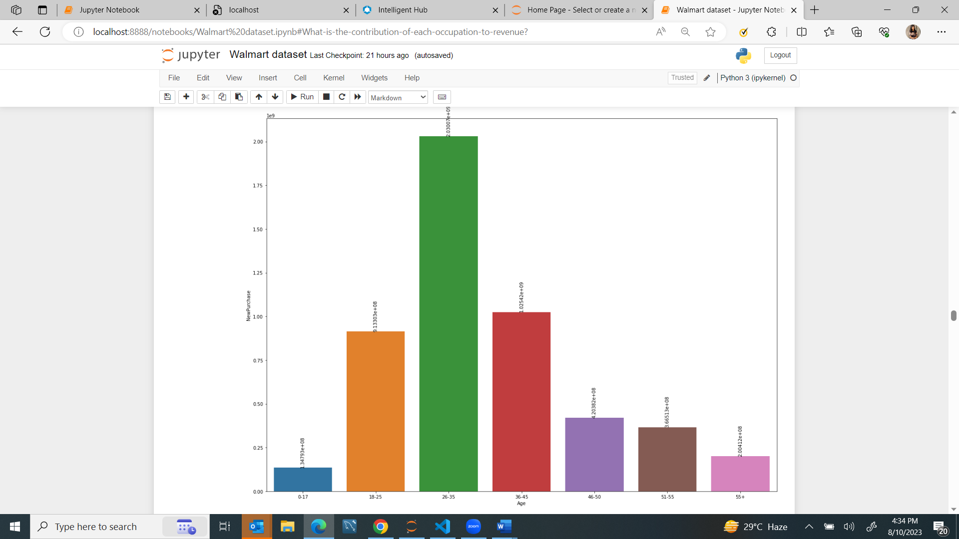

**What is the contribution of “stay years”to revenue?**

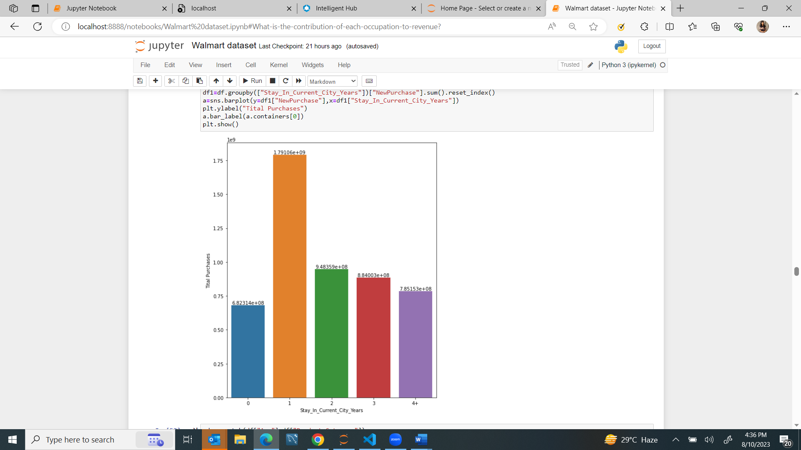

Observations on BIVARIATE ANALYSIS-

* customer staying in that city for 1 year are making higher purchases resulting in high revenue from those customers.
* Age group of 26-35 are contributing more to purchases
* The median value for purchases in all age group is approximately same
* 1,2,3,5,6,8,10,11,15,16 are the top 10 categories mostly contributing to total purchases.

MULTIVARIATE ANALYSIS-

**MALE/FEMALE PURCHASES IN EACH CITY**

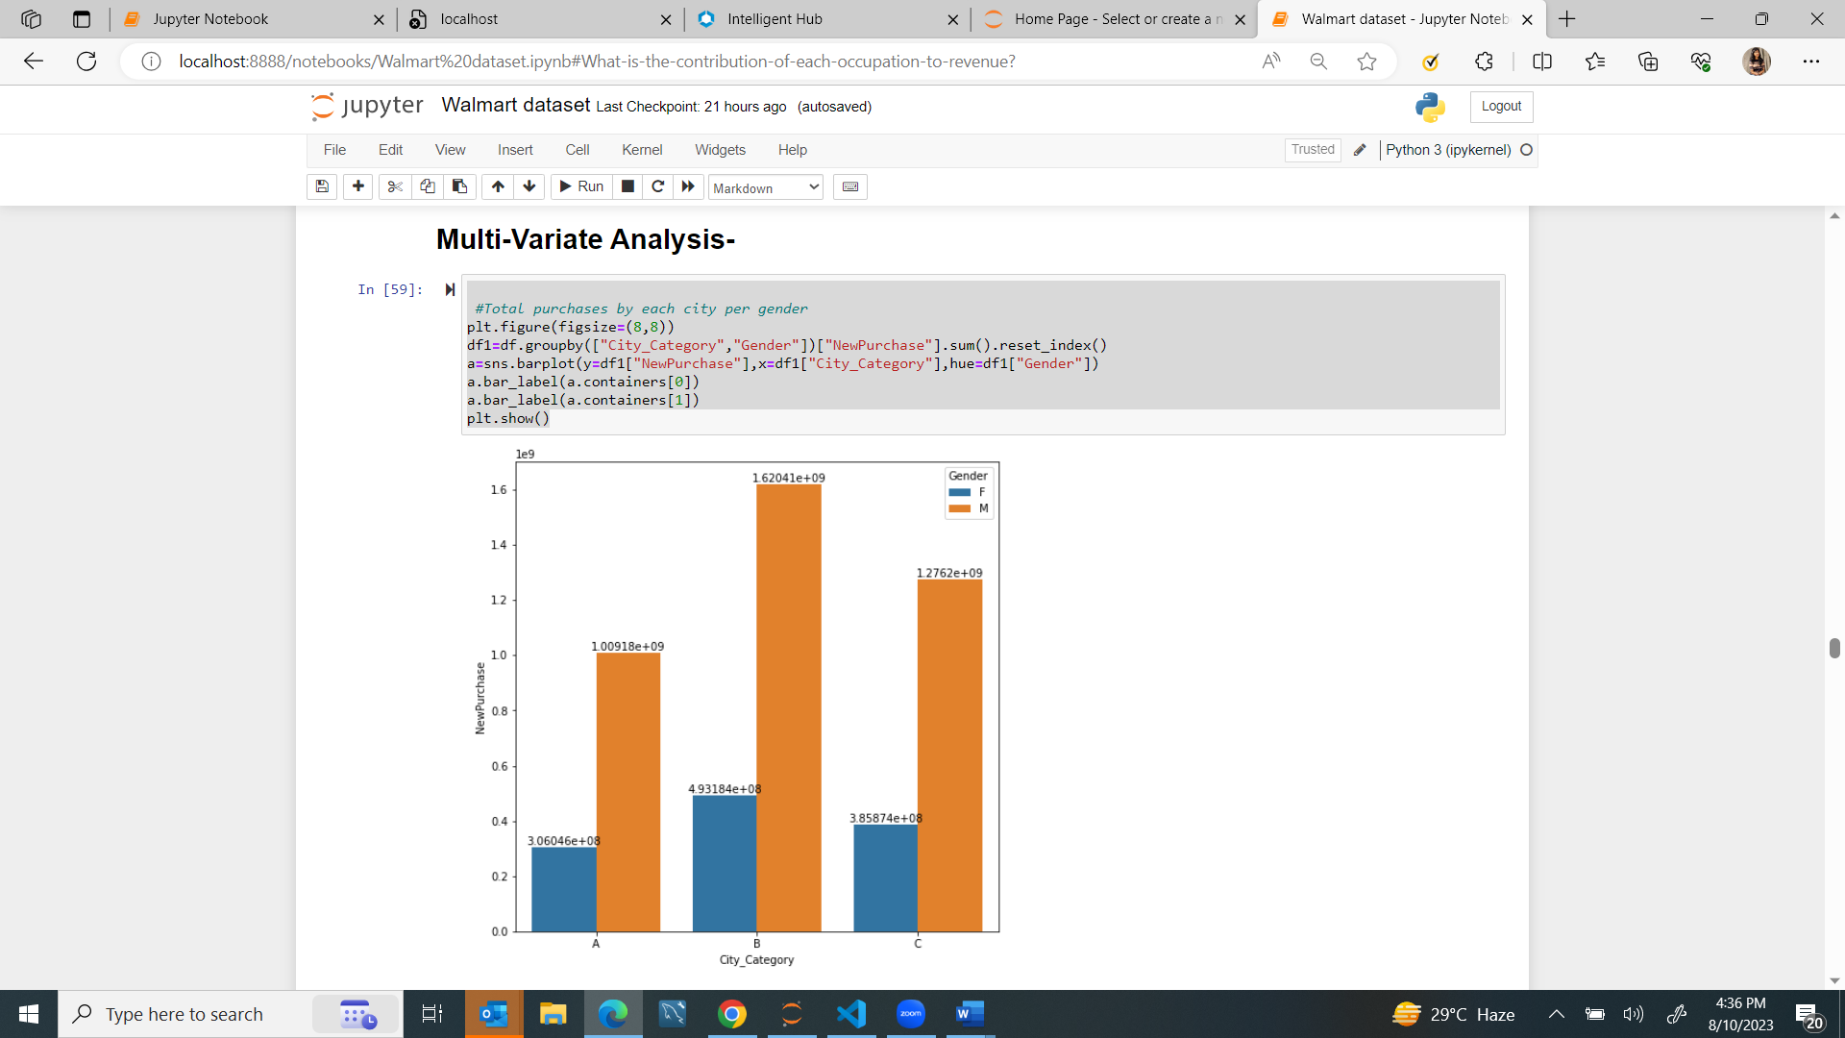

Observations-

In all three cities A,B,C -Males customers are making more purchases than females

**CATEGORY PREFERENCE BY EACH GENDER**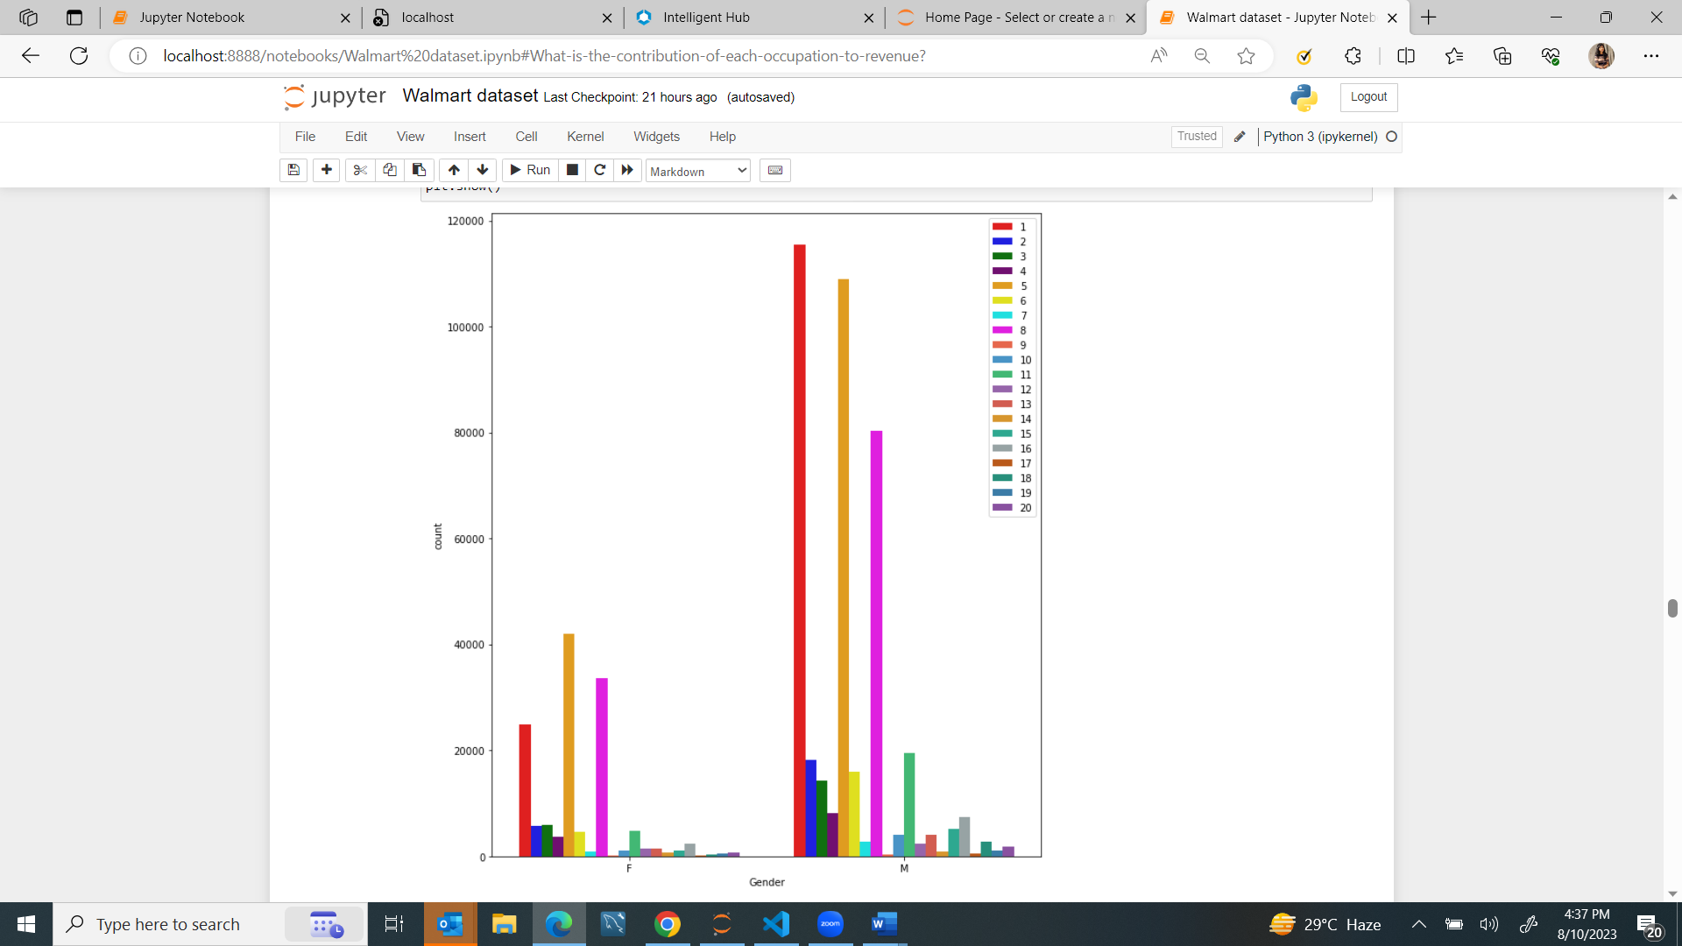

Observation-

* Product category 1 is purcahsed maximum number of times by males followed by 5 and 8
* Product category 5 is purcahsed maximum number of times by males followed by 8 and 1.

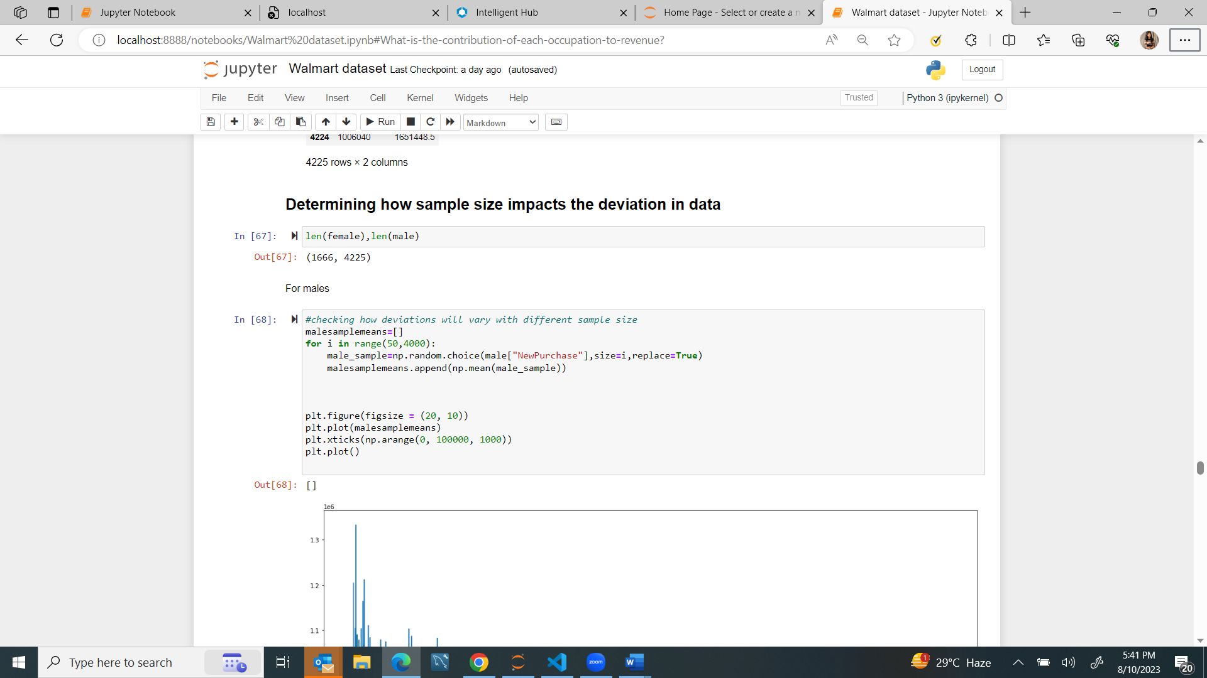

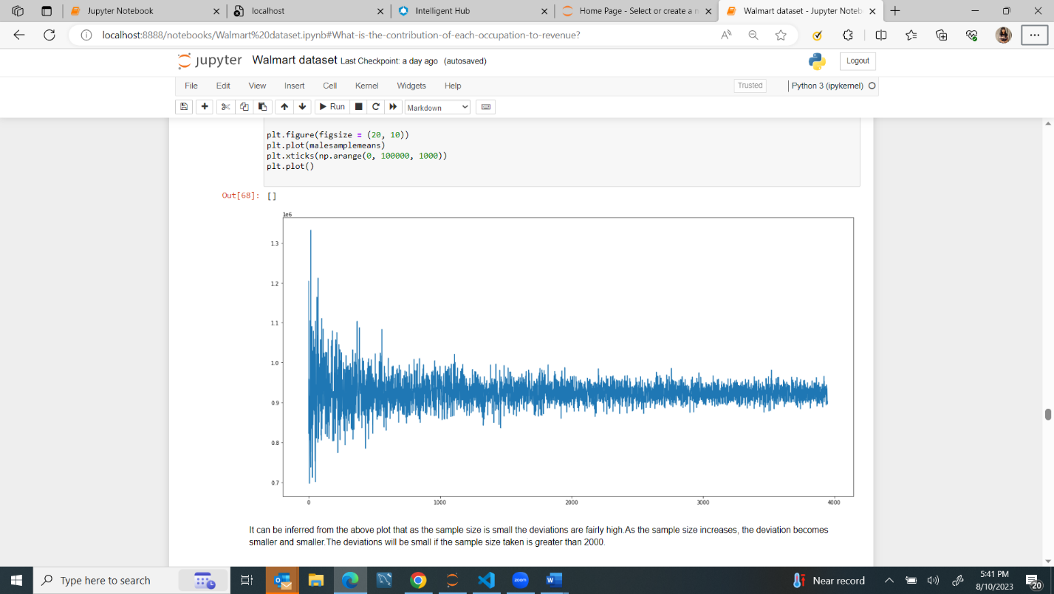**For males-**

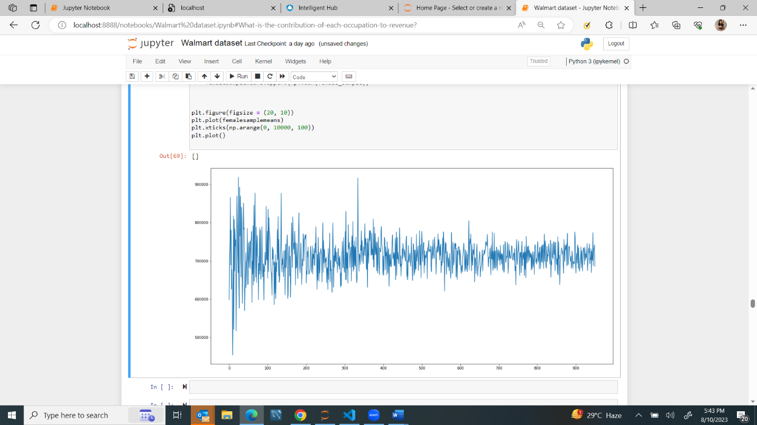**For females-**

**INFERENCE-**

It can be inferred from the above plot that as the sample size is small the deviations are fairly high.As the sample size increases, the deviation becomes smaller and smaller.The deviations will be small if the sample size taken is greater than 2000

**Are confidence intervals of average male and female spending overlapping?**

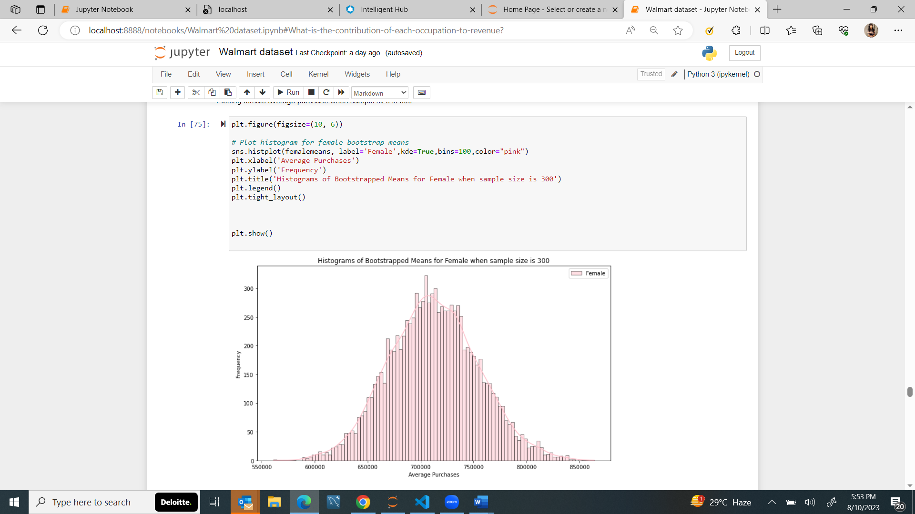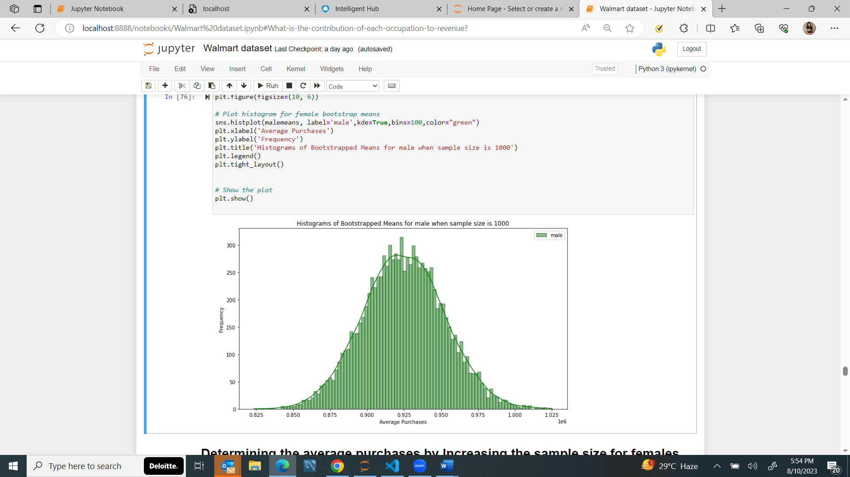*Determining Mean Purchase made by females and males with* ***sample size of 300 and 1000 taken 10000 times****:*

**Confidence interval is 90-**

With 90% confidence interval:

when sample size is 300 for female :

Average purchases for female will lie in range : [644625.07308333 - 782160.18041667]

With 90% confidence interval:

when sample size is 1000 for male :

Average purchases for female will lie in range : [880158.597525- 970519.75505

**Confidence interval is 95-**

With 95% confidence interval:

when sample size is 300 for female :

Average purchases will lie in range : [631287.946375 796763.20954167]

With 95% confidence interval:

when sample size is 1000 for male :

Average purchases will lie in range : [871684.56145 978597.3444 ]

Inference –

A 90% confidence interval is narrower than a 95% confidence interval because it needs to capture the parameter with slightly less confidence and the intervals are not overlapping each other .

We will now increase the sample size-

*Determining Mean Purchase made by females and males with* ***sample size of 1500 and 3000 taken 10000 times respectively-***

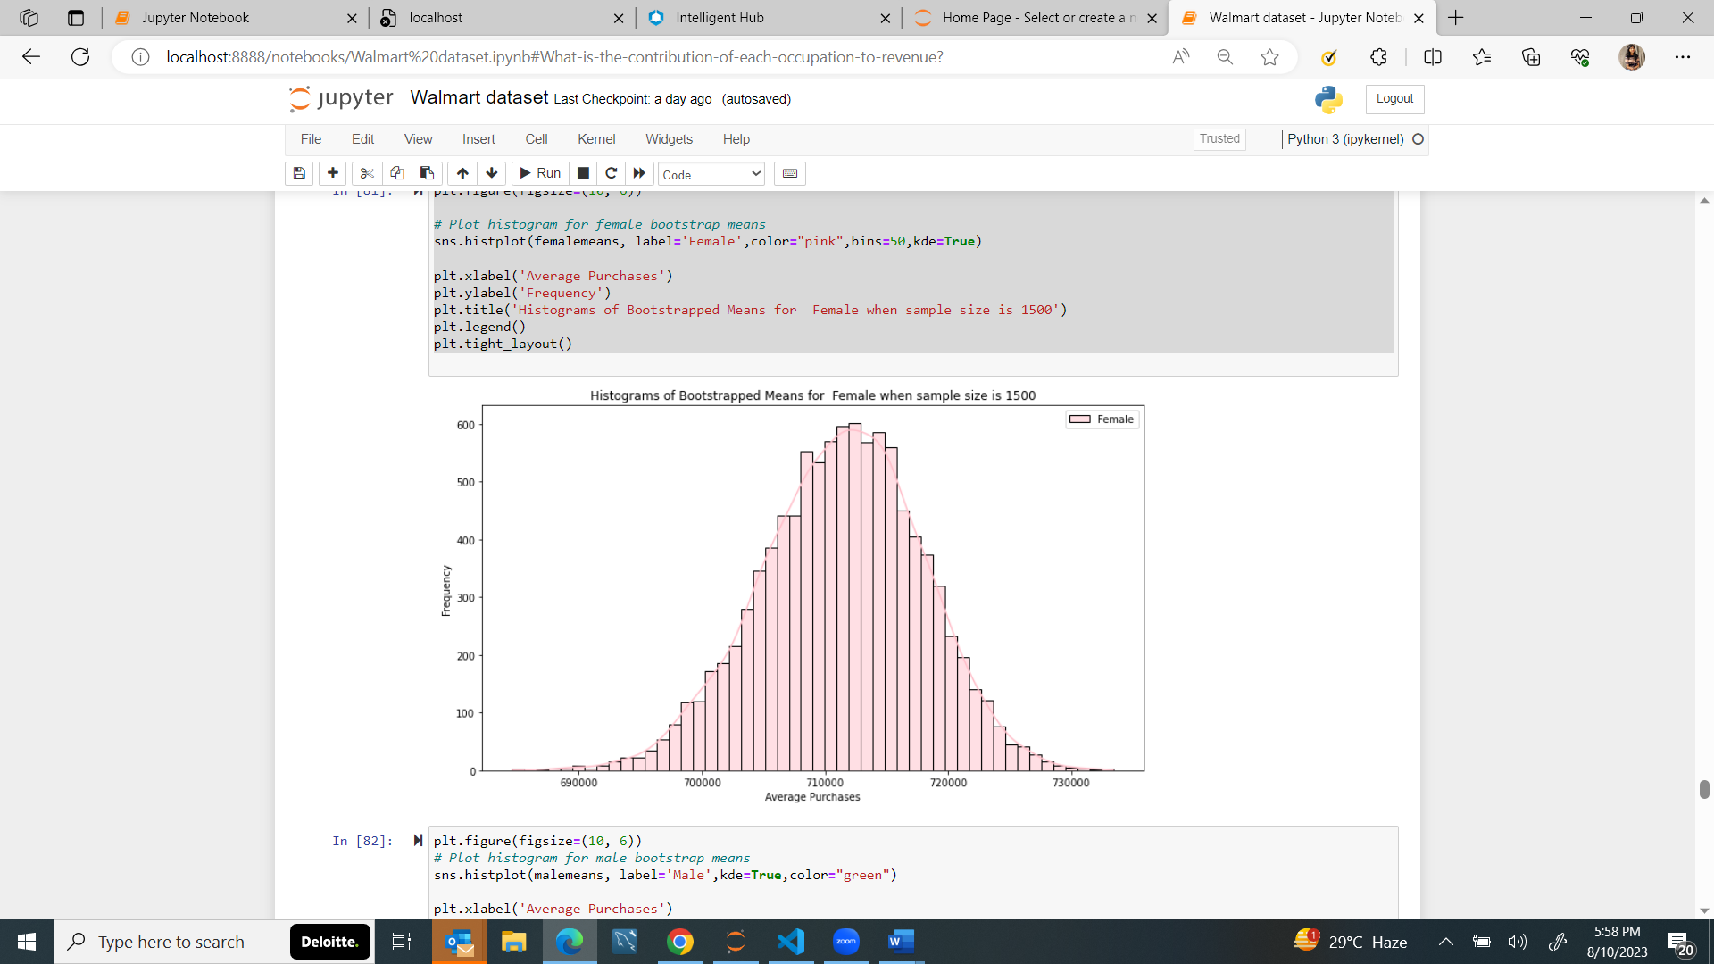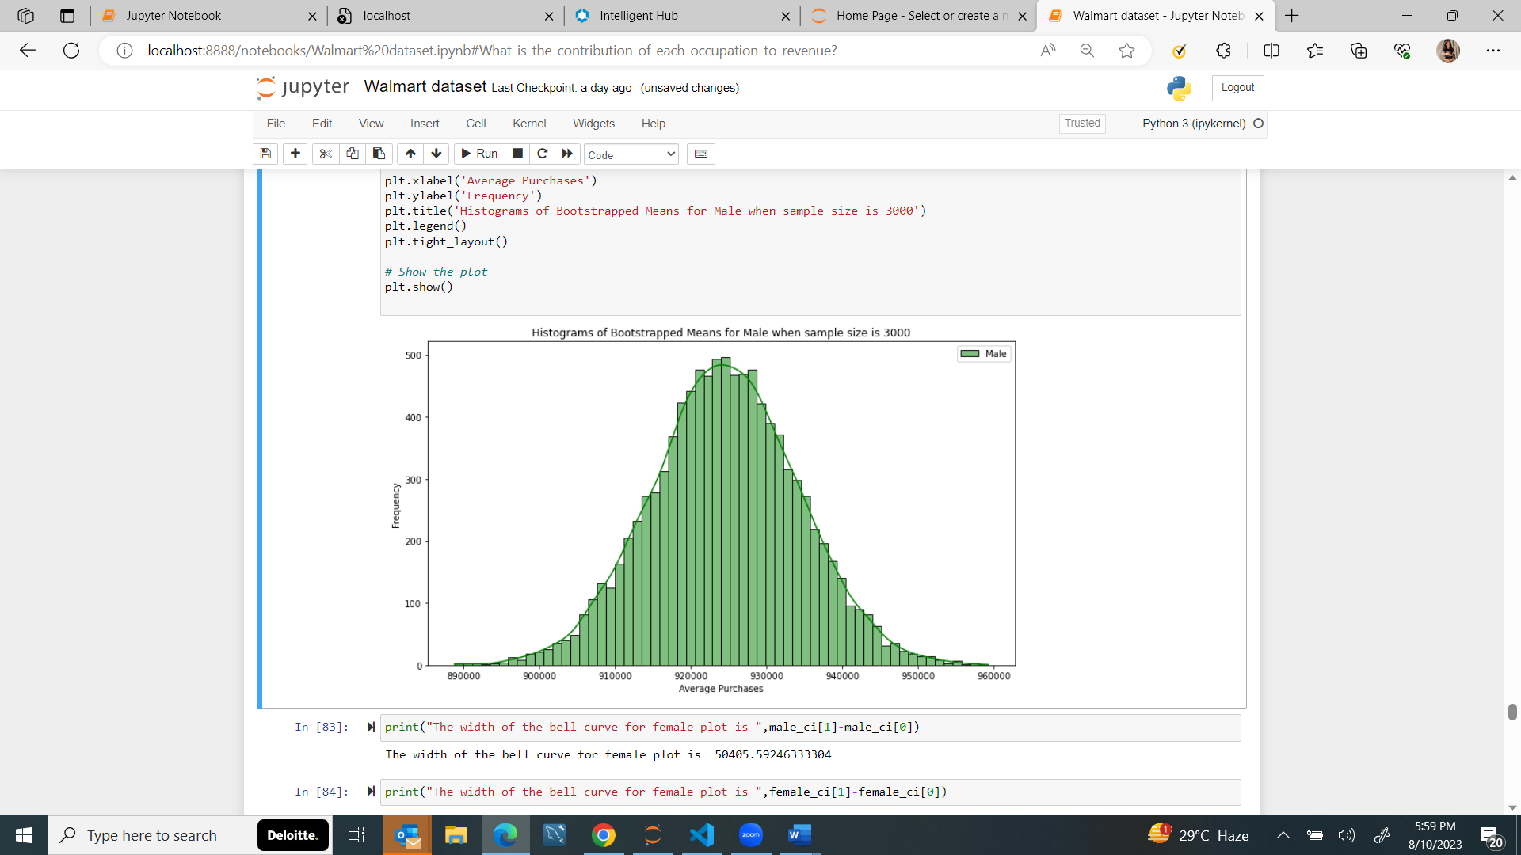

**90% interval**

With 90% confidence interval:

when sample size is 3000 for male :

Average purchases will lie in range : [908502.589725 940279.62633333]

With 90% confidence interval:

when sample size is 1500 for female :

Average purchases will lie in range : [700230.08406667 721635.22101667]

**95% interval**

With 95% confidence interval:

when sample size is 3000 for male :

Average purchases will lie in range : [905686.0237875 943394.26892917]

With 95% confidence interval:

when sample size is 1500 for female :

Average purchases will lie in range : [698192.46728333 723424.52106667]

**99% interval**

With 99% confidence interval:

when sample size is 3000 for male :

**Average purchases will lie in range : [899288.87259583 949694.46505917**]

With 99% confidence interval:

when sample size is 1500 for female :

**Average purchases will lie in range : [693625.53590167 726973.9921 ]**

**RECOMMENDATIONS-**

The intervals are still not overlapping each other which suggests that

Walmart could consider the following actions:

* Targeted Marketing: Tailor marketing campaigns based on gender-specific spending patterns to better cater to different customer segments.
* Product Placement: Adjust product placement in the store based on the preferences of different genders.
* Pricing Strategies: Optimize pricing strategies to align with gender-specific spending behaviors.
* Customer Experience: Customize the shopping experience to better match the preferences and behaviors of male and female customers.

While gender differences in spending might be observed, they could be influenced by various factors beyond just gender. It's crucial for Walmart to conduct further analysis and consider a holistic approach to making changes or improvements .

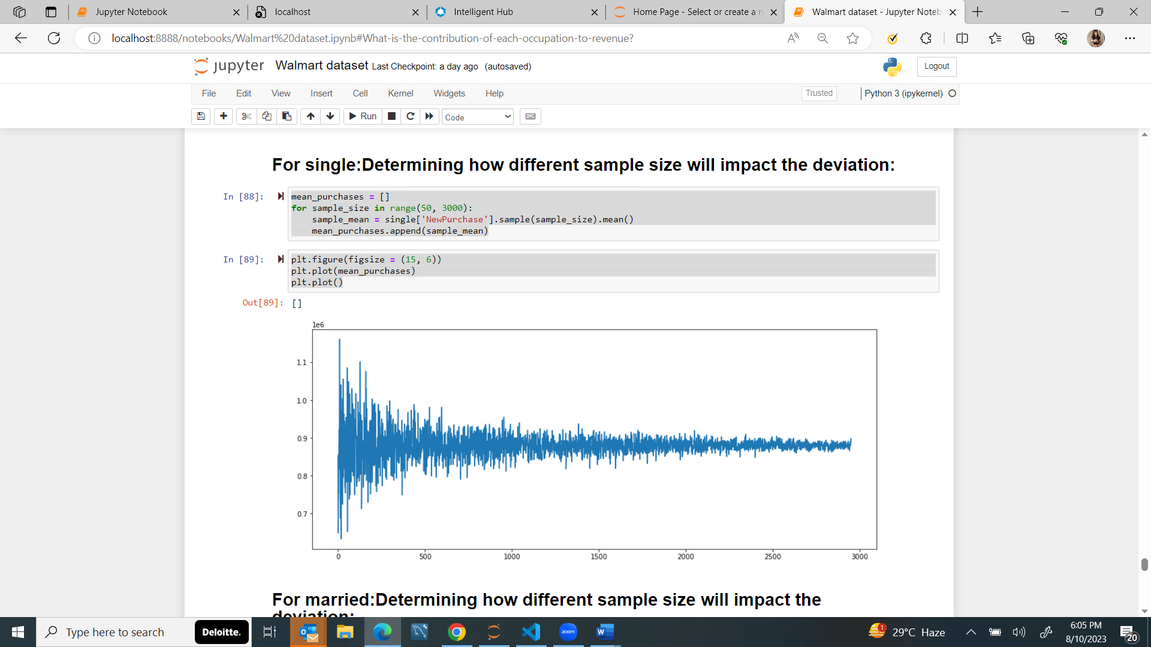

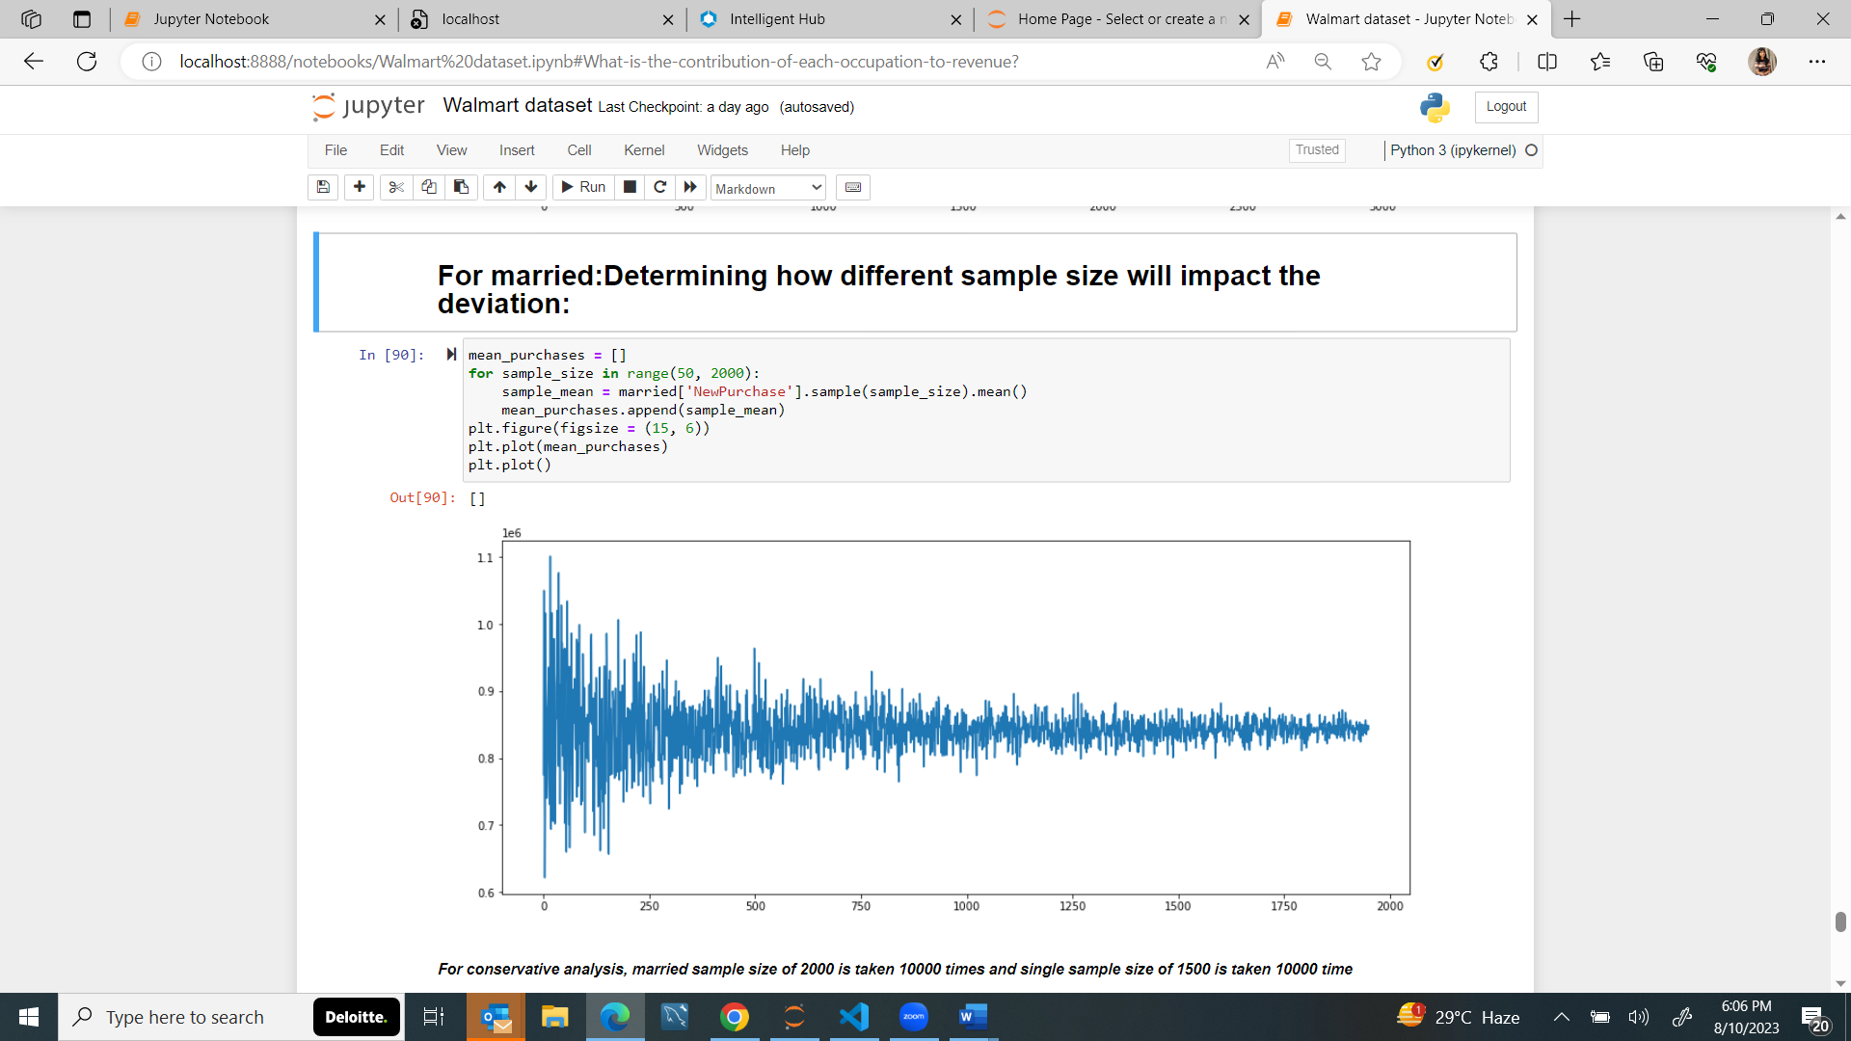

**For conservative analysis, married sample size of 2000 is taken 10000 times and single sample size of 1500 is taken 10000 time**

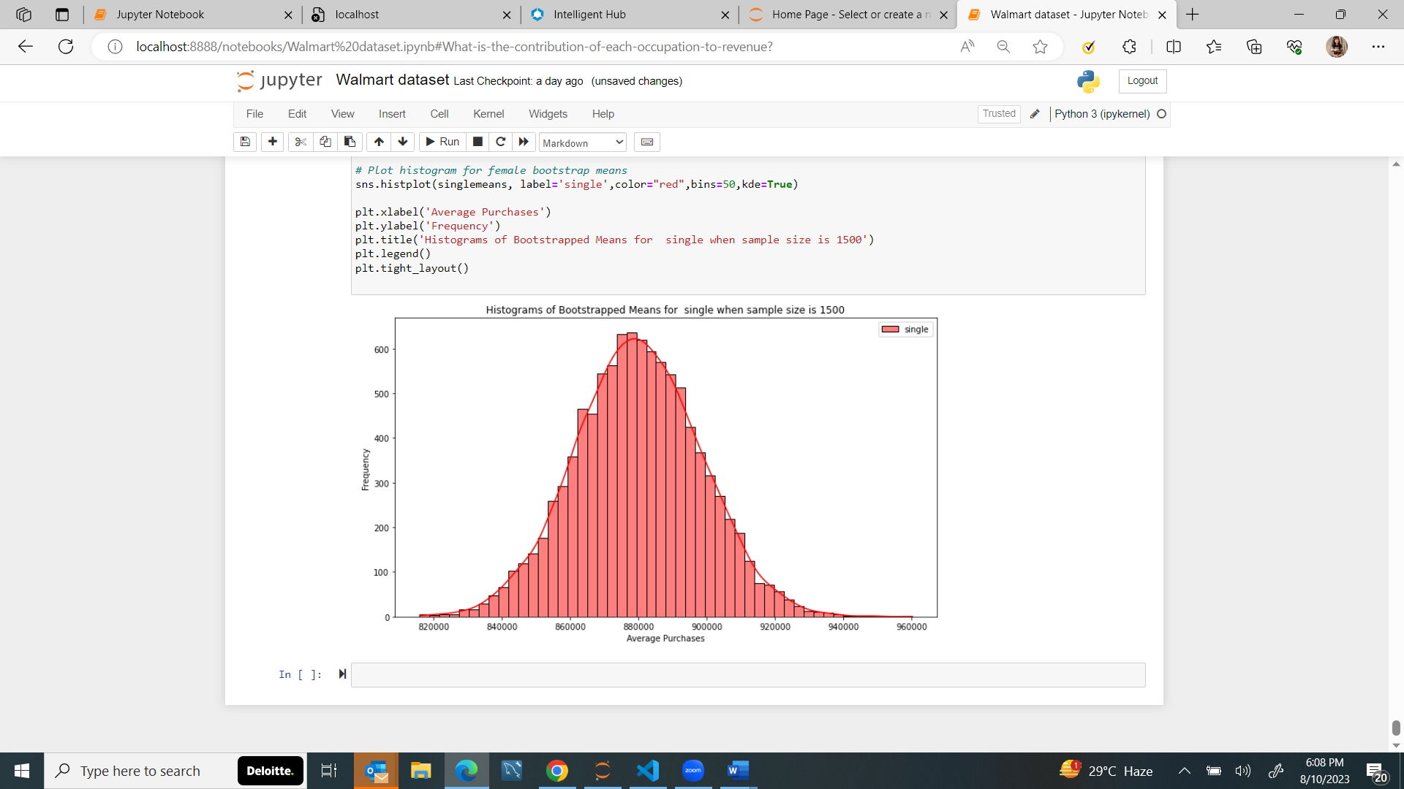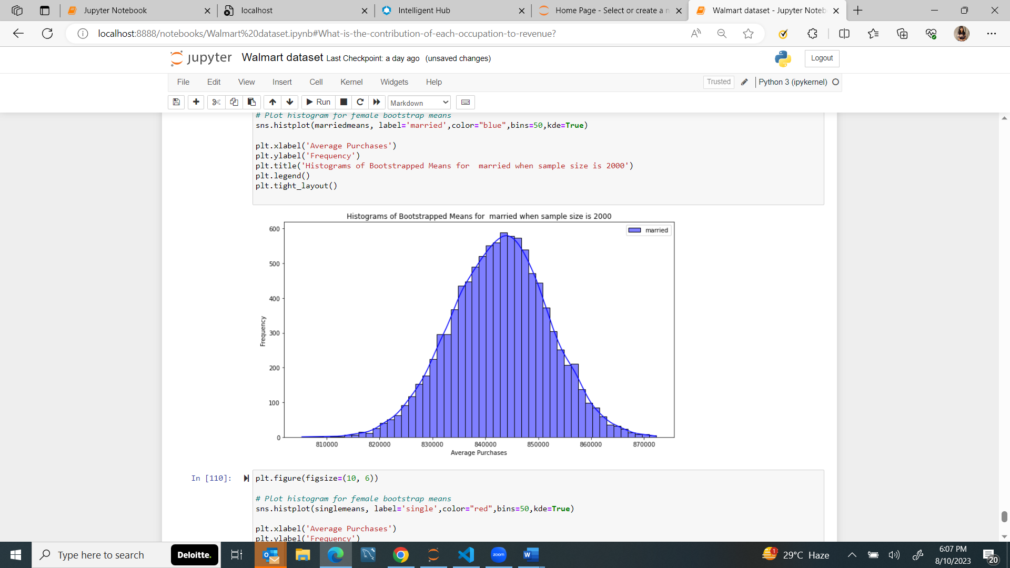

***With 95% confidence interval:***

when sample size is 1500 for **single** :

Average purchases will lie in range : [843581.287775 916092.431025]

when sample size is 2000 for **married** :

Average purchases will lie in range : [824524.4845875 860548.1926125]

**INFERENCE-**

This interval suggests that there might not be a statistically significant difference in spending between the two groups.

**SUGGESTIONS**

In this case, Walmart can leverage this conclusion to make informed decisions about their strategies and improvements:

**Targeted Marketing Campaigns:** Since there is no significant difference in spending between married and single customers, Walmart can design marketing campaigns that appeal to both groups equally. This might involve creating advertisements and promotions that resonate with a broader customer base.

**Product Variety and Placement:** The overlapping confidence intervals indicate that both groups have similar spending patterns, so Walmart doesn't need to drastically alter product placement or assortment based on marital status.

**Promotions and Loyalty Programs:** Develop promotions, loyalty programs, and discounts that are applicable and attractive to both married and single customers. Since spending patterns are similar, these initiatives can be designed to benefit a broader customer base.

**Determining the mean purchase made by each user per transaction based on their age groups :**

(Taking sample size significantly large to estimate the population mean**-)**

**For age 0-17:**

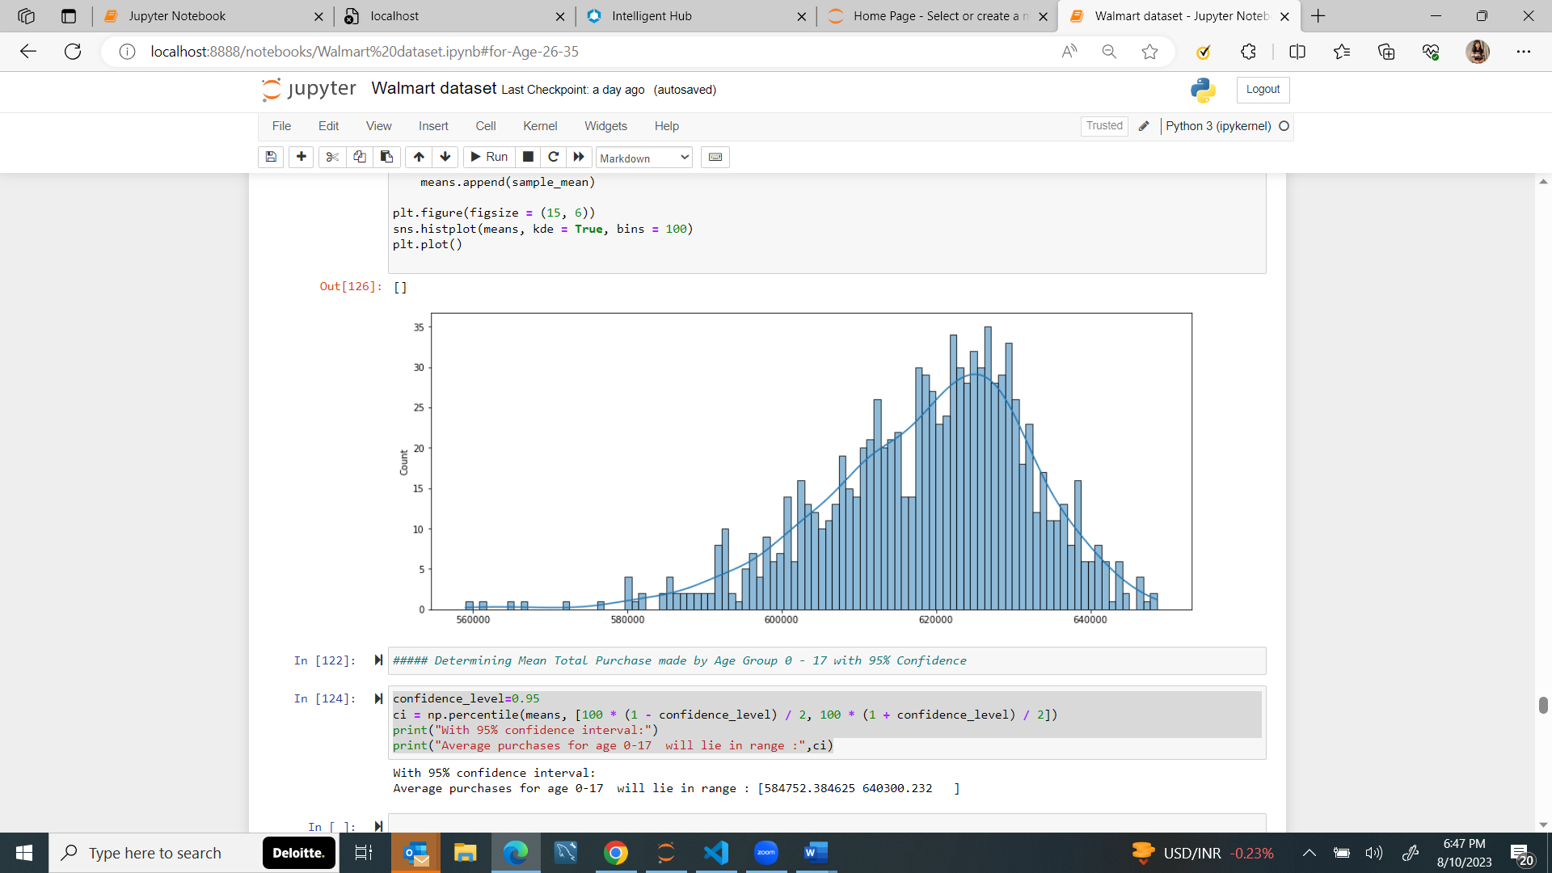

**With Confidence interval of 95-**

With 95% confidence interval:

Average purchases for age 0-17 will lie in range : [584752.384625 640300.232 ]

**Age 18-25:**

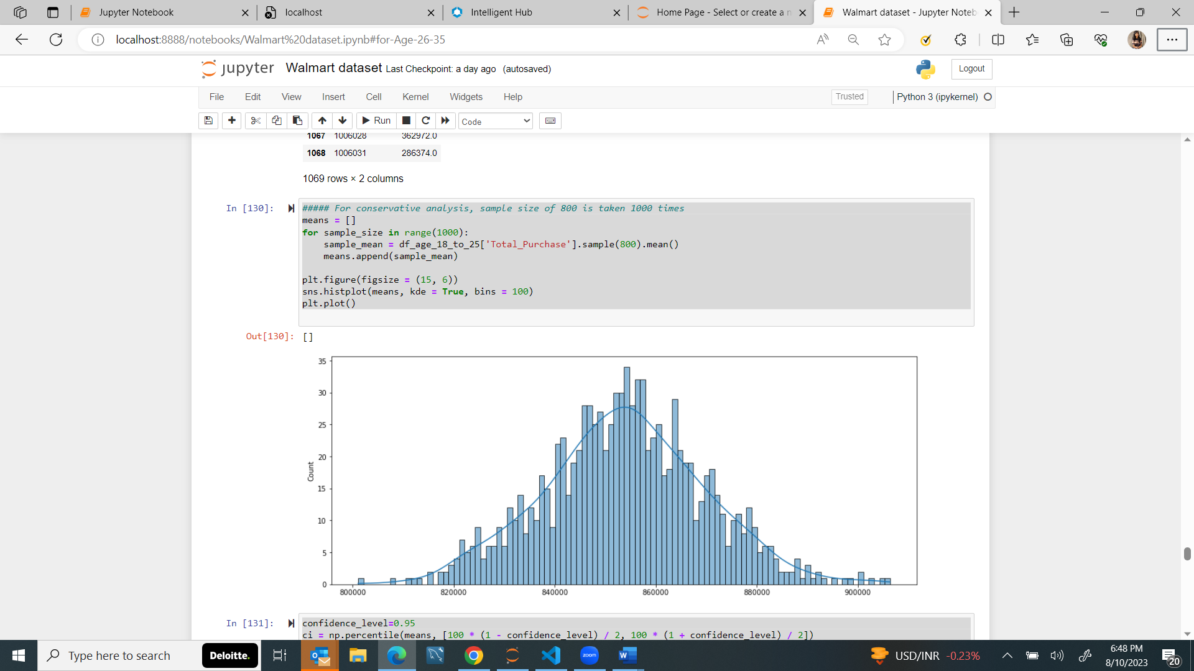

With 95% confidence interval:

Average purchases for age 18-25 will lie in range : [822324.85315625 884654.96448437]

**Age 26-35:**

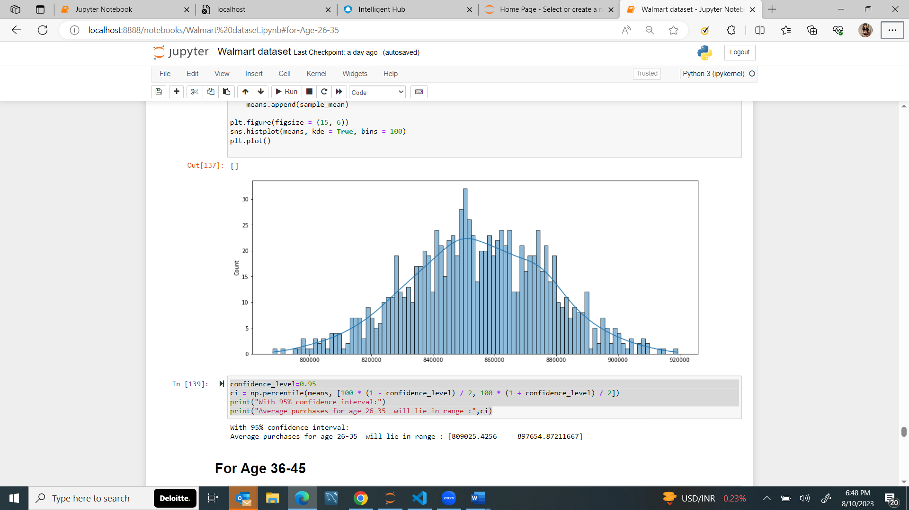

With 95% confidence interval:

Average purchases for age 26-35 will lie in range : [809025.4256 897654.87211667]

**For age 36-45:**

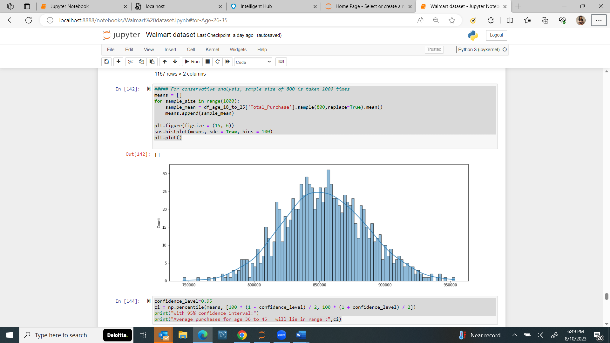

With 95% confidence interval:

Average purchases for age 36 to 45 will lie in range : [792331.65570313 917927.5301875 ]

**For age 46 to 51:**

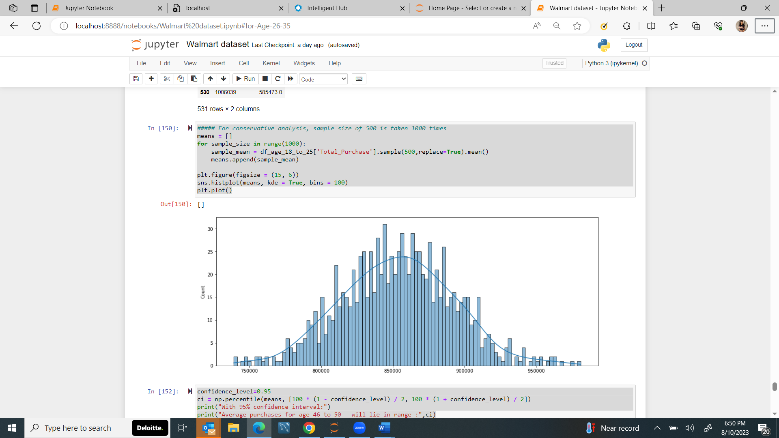

With 95% confidence interval:

Average purchases for age 46 to 50 will lie in range : [777697.88975 930608.31535]

**For age 51 to 55:**

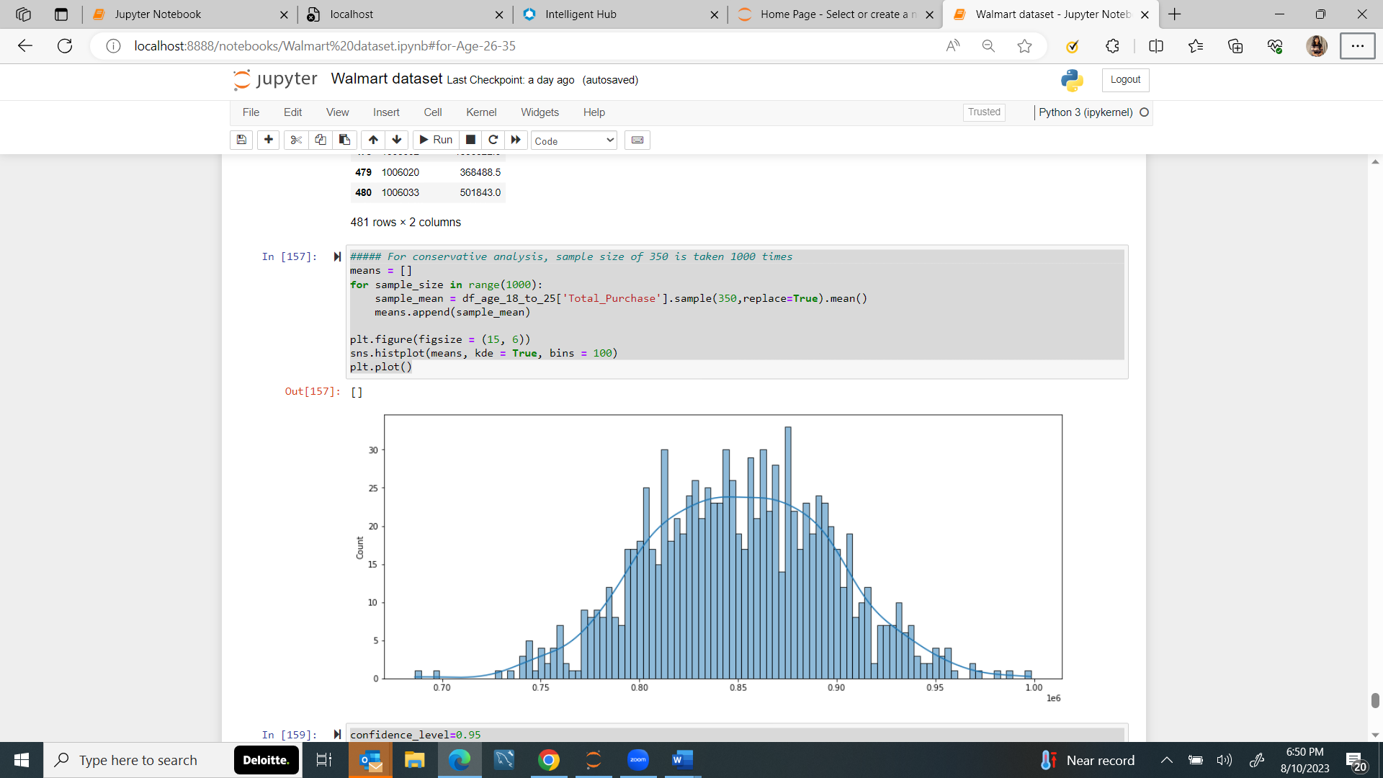

With 95% confidence interval:

Average purchases for age 51 to 55 will lie in range : [758926.38375 938586.17982143]

**For age 55+:**

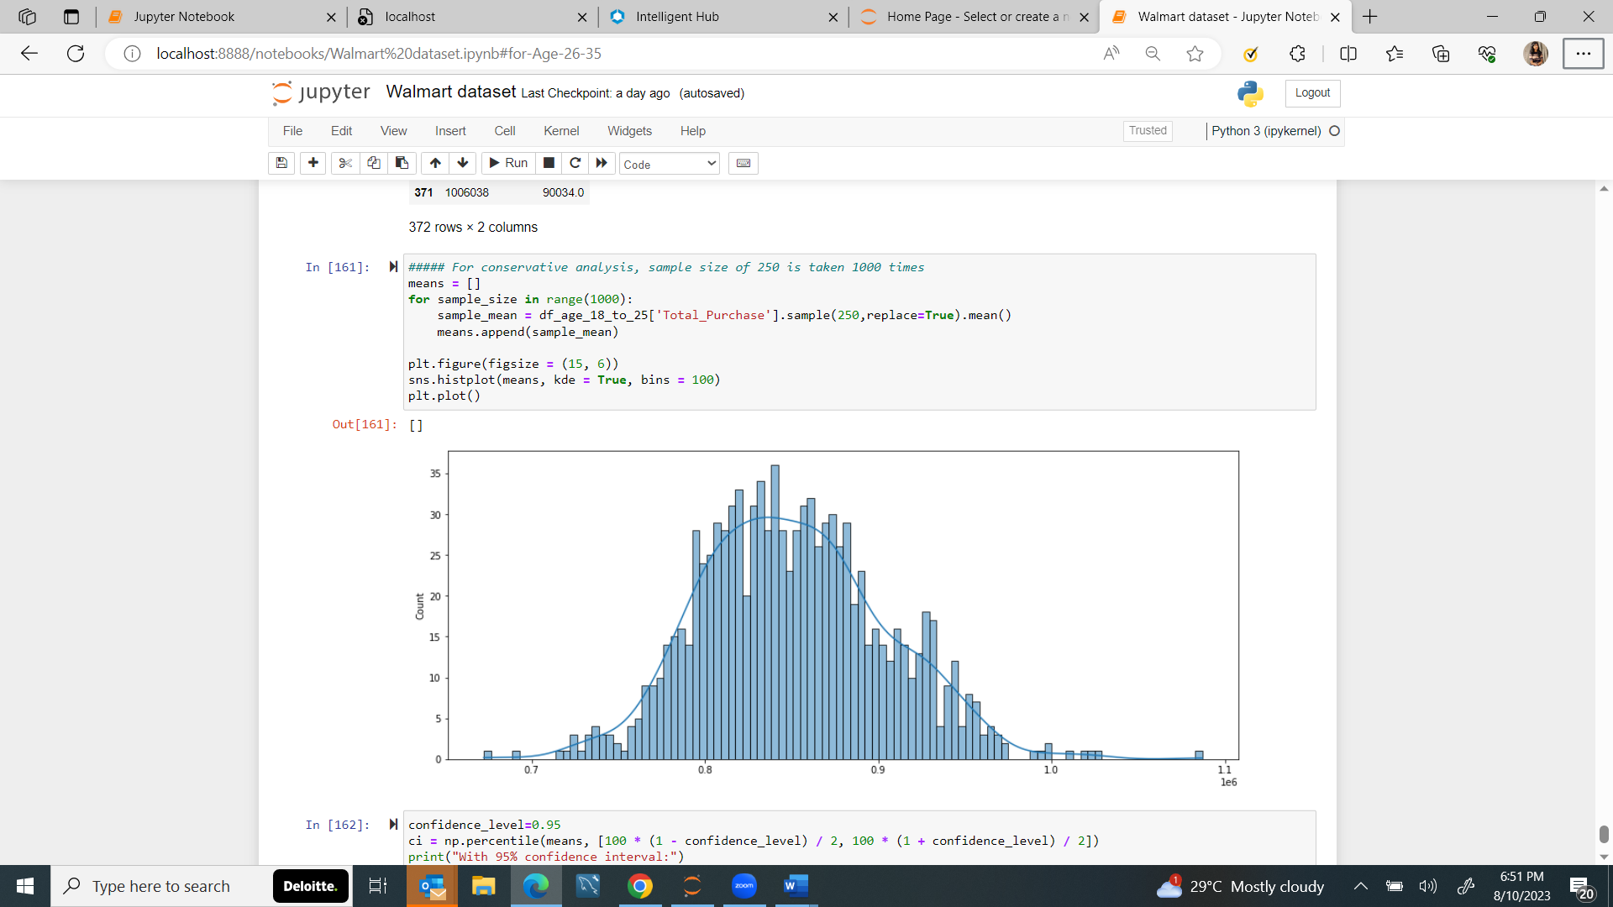

With 95% confidence interval:

Average purchases for age 55 above will lie in range : [755604.0879 955840.9671]

OVERALL ACTIONABLE INSIGHTS

* + Out of every four transactions made on Black Friday in the Walmart stores, three are made by the males and one is made by the females.
  + 82.33 % of the total transactions are made by the customers belonging to 11 occupations. These are 4, 0, 7, 1, 17, 20, 12, 14, 2, 16, 6 (Ordered in descending orderof the total transactions' share.)
  + Majority of the transactions are made by the customers having 1 or 2 years of stay in the current city.
  + The top 5 selling categories are, 5, 1, 8, 11 and 2.
  + There are 1666 unique female customers and 4225 unique male customers. Average number of transactions made by each Male on Black Friday is 98 while for Female it is 82.
  + On an average each male makes a total purchase of 712024.394958 on Black Friday while for each female the figure is 925344.402367.
  + 76.72 % of the total revenue is generated from males.
  + Out of 5891 unique customers, 42 % of them are Married and 58 % of them are Single.
  + 59.05 % of the total revenue is generated from the customers who are Single.
  + Majority of the transactions are made by the customers whose age is between 26 and 45 years.
  + Out of all unique customers, 35.85 % belong to the age group of 26 - 35 years, 19.81 % belong to the age group of 36 - 45 years, 18.15 % belong to the age group of 18 - 25 years, 9.01 % belong to the age group of 46 - 50 years.
  + Walmart generated 86.21 % of total revenue from customers in range 18 to 50 years on Black Friday.
  + Walmart generated maximum of the total revenue from the customers belonging to the city B, followed by city C and from city A on Black Friday.

OVERALL RECOMMENDATIONS –

* Since the average total purchase made by males is greater than females, Walmart should give special attention to their choices of products so as to retain them.
* Since Majority of the total transactions are made by the customers belonging to the occupations 4, 0, 7, 1, 17, 20, 12, 14, 2, 16, 6, Walmart should keep on adding new quality products related to their field of work.
* Since 82.43% of the total transactions are made for the Product Categories 5, 1, 8, 11 and 2, Walmart can earn more profits if they add new products in these product categories.
* Since 76.72 % of the total revenue is generated from males, Walmart should give special discounts to males on occasions like International Men's Day (19th Nov).
* Early Bird Deals: Offer exclusive early bird deals to attract customers who are eager to start shopping as soon as the sale begins.
* Flash Sales: Introduce time-limited flash sales throughout the day to create a sense of urgency and excitement among shoppers.
* Online and In-Store Integration: Provide online and in-store experiences, allowing customers to browse online and pick up items in-store or vice versa.
* Personalized Recommendations: Utilize customer data to offer personalized product recommendations based on past purchases and browsing behavior.
* Bundle Deals: Create bundle deals where customers can purchase complementary products at a reduced price when bought together.
* Extended Shopping Hours: Extend store hours on Black Friday to accommodate shoppers who want to shop at different times of the day.
* Social Media Engagement: Utilize social media platforms to create excitement for the sale